Developing Value Systems

We need to think about people and their communities develop a set of values that are reflected in the way in which both individuals and societies evolve. First, let’s think what we might mean by beliefs, which in turn influence values.

Are there some common values that most societies accept as part of their domestic code for living in reasonable harmony with other members of that society?

beliefs of a person or social group in which they have an emotional investment’

A core set of values, such as the sanctity of life and the punishment needed to react against those who deliberately end the life of another human being develop what we might think of as assumptions, convictions, or beliefs about the manner in which people should behave and the principles that should govern behaviour.

Once such values are established within a community individuals are expected to;

Accept these as the general guiding principles that are to govern all activities.

However, to be accepted by the majority of the population and therefore applied evenly within them values and beliefs must:

Reflect those qualities of behaviour, thought, and character that society regards as being intrinsically good, having desirable results, and worthy of emulation by others.

Let’s stop and think about what we have just read. Put simply as societies ‘evolve’ so they develop characteristics which mould their value systems. By being a member of that society or community you automatically become bound by such ‘core’ values.

So, we need to ask if some values appear regularly in the majority of societies, regardless of their location.
It appears that some values are inherent in most societies, though they do differ.

The map that follows is an attempt to measure similarities within societies and also to identify what characteristics govern, shape the core values held within such societies.

The survey identified two major sets of values that allowed its contributors to differentiate societies. These were: (a) Traditional/ Secular-rational and (b) Survival/Self-expression values. It might surprise you but these two dimensions explain more than 70 percent of the cross-national variances that exist in surveys conducted in over 100 countries...
The Traditional/Secular-rational values dimension reflects the contrast between societies in which religion is very important and those in which it is not. A wide range of other orientations are closely linked with this dimension. Societies near the traditional pole emphasize the importance of parent-child ties and deference to authority, along with absolute standards and traditional family values, and reject divorce, abortion, euthanasia, and suicide. These societies have high levels of national pride, and a nationalistic outlook. Societies with secular-rational values have the opposite preferences on all of these topics.
The second major dimension of cross-cultural variation is linked with the transition from industrial society to post-industrial societies-which brings a polarisation between Survival and Self-expression values. The unprecedented wealth that has accumulated in advanced societies during the past generation means that an increasing share of the population has grown up taking survival for granted. Thus, priorities have shifted from an overwhelming emphasis on economic and physical security toward an increasing emphasis on subjective well-being, self-expression and quality of life. Surveys have shown evidence that orientations have shifted from Traditional toward Secular-rational values, in almost all industrial societies. But modernisation, is not linear-when a society has completed industrialization and starts becoming a knowledge society, it moves in a new direction, from Survival values toward increasing emphasis on Self-expression values.
A central component of this emerging dimension involves the polarisation between Materialist and Post materialist values, reflecting a cultural shift that is emerging among generations who have grown up taking survival for granted. Self-expression values give high priority to environmental protection, tolerance of diversity and rising demands for participation in decision making in economic and political life. These values also reflect mass polarisation over tolerance of out groups, including foreigners, gays and lesbians and gender equality. The shift from survival values to self-expression values also includes a shift in child-rearing values, from emphasis on hard work toward emphasis on imagination and tolerance as important values to teach a child. And it goes with a rising sense of subjective well-being that is conducive to an atmosphere of tolerance, trust and political moderation. Finally, societies that rank high on self-expression values also tend to rank high on interpersonal trust.
This produces a culture of trust and tolerance, in which people place a relatively high value on individual freedom and self-expression, and have activist political orientations. These are precisely the attributes that the political culture literature defines as crucial to democracy.

Now, what has been briefly outlined above might appear rather complicated but put simply it means that as economies and the societies that operate within them begin to move away from simply living to survive so values within them alter.
As potential leaders of tomorrow you need to:
- recognise these
- think of ways of adjusting to this process – if it one that you feel is inevitable within your own country or community

We need to think about such sensitive areas of communal life as:

  - gender
  - initiation rituals
  - education for everyone, regardless of ethnicity, sex, age or any other determinants
  - expectations
  - how such ambitions can be made a reality

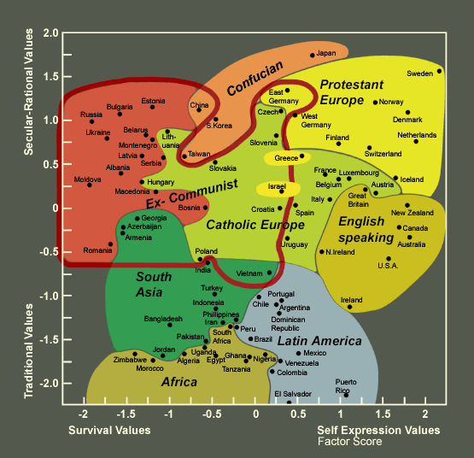

The World Values Survey has produced evidence of gradual but pervasive changes in what people want out of life. Moreover, the survey shows that the basic direction of these changes is, to some extent, predictable.
Such a large survey as that conducted by the World values Survey cannot be analysed in the short space available to us her but if you would like to read more on its finding click on to:
http://wvs.isr.umich.edu/fig.shtml
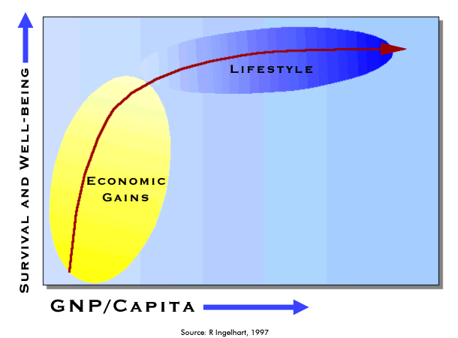

So we can see that as material standards increase so people start to ask different questions both of themselves and the society within which they live.

Perhaps now is the time to pose some questions to those working through what might be quite a difficult read!

- What is the level of your Gross National Product and how evenly is it distributed i.e. what is Average Gross National Product.
- How influential are ‘traditional values’ in your society and which of these would you select as being predominant?
- How has the role of women altered over the past two decades?
- Do women feature in positions of high public life?
- What proportion of your population live and work on the land?
- What proportion of your GDP is generated by manufacturing industry?
- What proportion of your population finishes secondary school?
- What proportion of your population proceeds to higher education?
- What proportion of your GDP is spent on (a) health care (b) education and (c0 social welfare?
- What proportion of your GDP is spent on defence?

Now, start to imagine just what kind of society your country might resemble in (a) 10 years time and (b) 25 years time. You might like to ponder on such topics as:

  - abortion and family planning
  - care of the elderly
  - trust, transparency and accountability of both individuals to one another and of those in public positions to their fellow citizens
  - attitudes to different groups within your country and those living in neighbouring countries
  - access to communication facilities

We can develop some of these and others you may want to include when we go ON LINE in the coming weeks.

