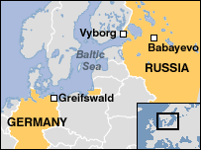

Germany and Russia sign gas agreement

The building of the pipeline began on the pipeline on Friday. The project has caused concern in the Baltic countries, Poland and Ukraine. It will send Russian gas to Germany and other West European nations by 2010. Russia supplies a quarter of the region's gas needs. With limited natural resources of its own, Germany's dependency is even greater and Europe's biggest economy relies on Russia for a third of all its oil and gas imports. The $5bn (£2.7bn) deal was struck between the two countries' leaders last September, just before Mr Schroeder lost power. The 1,200km pipeline will run from the northern Russian town of Babayevo to the coast at Vyborg before going under the Baltic Sea to the town of Greifswald in north-eastern Germany.
It is set to bypass Poland and Ukraine, prompting concern from both countries that they will be cut off from Russian gas supplies.

