The European Parliament

It’s Powers
The parliament amends, approves or rejects EU laws, together with the Council of Ministers. The process of "co-decision" - by which a law is only passed when approved by both bodies - applies in areas including consumer protection, the single market, workers' rights, asylum and immigration, the environment and animal welfare, but not foreign policy or agriculture. The parliament also shares authority over the EU budget with the Council of Ministers and supervises other EU institutions, including the Commission. It vets new commissioners, and can sack the commission en masse.

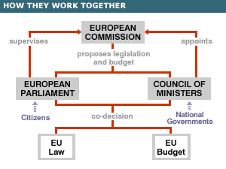

Locations

The parliament has two chambers - one in Brussels, the other in Strasbourg - and a secretariat in Luxembourg. For three weeks of the month the parliament operates in Brussels, where most committee and political group meetings take place, then for one week it decamps to Strasbourg. This perpetual movement adds to the cost of running the parliament, and is unpopular with members of the European Parliament (MEPs), because of the extra travel involved. However, the Strasbourg parliament is a matter of national prestige for France. Situated on the border between Germany and France, which fought two world wars in the last century, it is also a symbol of Europe's peaceful new order.

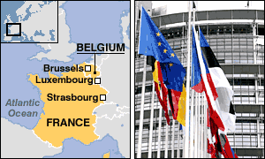

Party groups

Most MEPs belong to one of the parliament's political groups. None has an overall majority, so amendments need the support of more than one group to get through. On most issues the parliament divides along classic left-right lines. A group must have at least 16 members, from one fifth of member states. The larger the group, the more funding it receives the more key committee posts it gets and the longer it can speak in debates. Some groups are broad churches: the EPP-ED includes euro-enthusiast Christian Democrats and euro sceptic British Conservatives while the UEN includes the moderate Irish Fianna Fail party and Italy's post-fascist National Alliance.

Political Groups – web sites

EPP-ED
PES
ALDE
EUL/NGL

Greens/EFA
UEN
IND/DEM

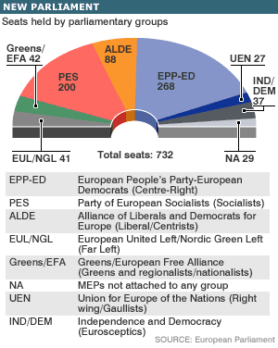

Enlargement
Before enlargement on 1 May 2004 the parliament had 626 seats. The new parliament elected in June 2004 has 732, and it will grow again when Bulgaria and Romania join, possibly in 2007. As 162 new MEPs from new member states have taken their seats, most of the older member states have lost a few members of parliament - Germany avoided this fate because it had the fewest seats per head of population. Enlargement puts huge new burdens on the parliament's translation service, which must now provide simultaneous translation of all debates into 20 languages. This amounts to 190 different language combinations - Finnish-Czech, German-Portuguese, English-Maltese and so on. From now on, more translations will take place through a third language, such as English or French.

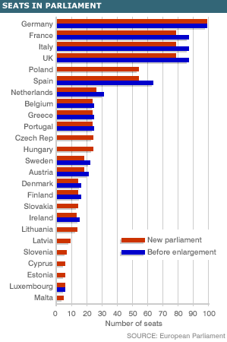

Salaries and expenses

MEPs receive the same salary as members of their national parliaments. As a result, Italian MEPs earn four times as much as their Spanish counterparts - and about 14 times more than MEPs from some new member states. Unofficially, it is accepted that MEPs on lower salaries will supplement their incomes from their expenses budget. MEPs get 150,000 euros per year for office expenses and are not obliged to account for this expenditure. They are also reimbursed for full-price air travel to and from their home country even if they fly by low-cost airline. An attempt to reform the expenses system and agree a flat salary of 8,600 euros per month for all MEPs was blocked by Germany in 2004, on the grounds that the proposed new salary was too high and the overall bill would be too big.

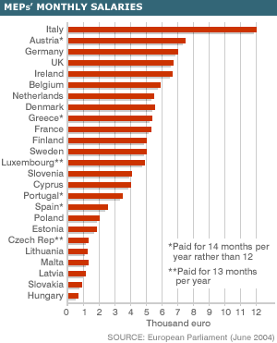

Turnout at Parliament Elections

Since the first European election in 1979, voter turnout has been in steady decline.
The overall turnout figure in 1979 was 63%; in 2004 it was 45.7%. These figures mask very different participation rates between different member countries: turnout in Slovakia was 17% in 2004, compared with 73% in Italy. It was also high in Belgium, Greece and Luxembourg, where voting is compulsory. Over the same period, the number of people participating in national elections has also tended to drop, in some cases by 10% or more. While 76% of voters cast ballots in the UK's 1979 general election, only 59% turned out in 2001. In France, 71% voted in the 1980 parliamentary poll, compared with 60% in 2002. However, participation in European elections is lower than in national elections - by an average of 22% in the 15 older member states. In the new member states, which voted for the first time in the 2004 European election, this turnout gap averaged 29%. In the new member states, on average, only 27% of the electorate cast a vote in the 2004 election. In the other 15, turnout was 49.4% - about one half of a per cent down on 1999.

