WEEKLY REVIEW 26th SEPTEMBER 2005.

United Kingdom News

The battle for cheap fares takes on a costly re-route?
The cost of aviation fuel has risen considerably in recent months and for Virgin this has meant an increase in their costs of £300m a year over the last two years. One of the reasons given for this rise in price is the lack of oil refineries specialising in producing aviation fuel. With insufficient capacity prices will continue to rise. Though petrol prices have now slipped back from their post Katrina high Richard Branson is thinking of building his own aviation fuel refinery. Though such an investment would cost many hundred of millions one has to remember that Virgin’s fuel bill is running at £750 million a year. A saving of only 20% of current costs would make a significant impact of ticket prices. Of course building a refinery is easy to say but difficult to do. So, Sir Richard is keen to promote co-operation between EU governments and allow a genuine counterbalance to OPEC refineries, which he sees as operating a cartel. By agreeing a refinery building programme and promoting co-operation in buying schedules Branson feels that oil prices would drop in real terms – competition will drive down prices! He also wants tax breaks for firms researching fuel efficient and hydrogen driven vehicles. He does not want government to do anything too radical as this might cause a recession. However, he would like fuel inefficient airlines to be penalised.
Some questions

- Define (a) recession (b) cartel and (c) tax breaks.
- Why might insufficient capacity have caused prices of oil and therefore petrol to rise?
- What other factors will determine how much of any cost savings that arise from Branson’s idea will be passed onto customers?
- In what ways might government attempt to alter (a) the price of aviation fuel and (b) its use?

A very brief economic history of England. (Apologies to those who think I should have started in 1500!)

Was there really a starting point?

In the economic history of The British Isles 1600 is as a good a year as any to start. At that time Britain was not a major power in Europe or beyond. The most important country in northern Europe then was The Netherlands, which had influence both within Europe and much further a field. Indeed, it was probably the only match for the all conquering Ottoman Empire, which for over a little more than a hundred years had gained territory and influence across large parts of southern and Eastern Europe.
When trying to discover from whence came Britain's wealth it is always worth looking at the sea and its influence on how these islands came to be so dominant in world trade.
The start of the 1600's saw us fresh from success against the Armada and our ‘adventurers’ were beginning to explore far off lands. They were to ‘acquire’ some of the Spanish territories in the Caribbean and eventually develop India for the British, during which they expelled the French from what was then the largest single market in the world. In doing so they made English the most spoken language in the commercial world and transferred huge sums of money back to the United Kingdom Ironically, one of the most successful of these adventurers sailed on a Dutch boat and was not really looking for what he found. He was Henry Hudson, who like quite a number was looking for the route to China and untold riches. On his return to Britain he was told that never again must he sail with a foreign crew and so when he took to sea the next time he turned in the opposite direction and discovered the Hudson Bay area of what is now Canada. Elsewhere these brave people travelled to Botany Bay and other parts of the globe.
The sea was the supreme form of transport and the Dutch sailed out to the Far East. Alas, the sea was not only used for trade. Battles between the rival powers were often fought at sea, but as with many of the more recent inventions which shape our lives today war was a moderniser and ships began to be more robust, likely to reach their intended destination and capable of carrying increased loads.
In 1626 the Dutch bought Manhattan from the local Indians and the first seeds of modern New York were sown. Canals were dug and walls built to protect this newly established outpost of the Dutch Empire (hence Wall Street) and their domestic capital of Amsterdam became the richest city in the modern world. A new breed of sponsors of sea-borne missions was established and they were private financiers. The age of investment was dawning and with a relatively tolerant society the Dutch welcomed many other nationalities to their shores. They became the middlemen of world trade. They founded a national bank in 1609 but not all their excursions into world -wide capitalism ended as a success and in 1636 the bubble burst.
Though they continued to prosper the Dutch were missing one important element that the British had in abundance. This was coal. As a fuel it had been used for quite sometime but its smell led many to use wood. However, in what was to be a glimpse of future environmental problems the stock of wood began to diminish and so coal grew in popularity. With its increase in use came the need to transport the 'black stuff' in bulk and this was a major force behind the building of canals. It also was to become the backbone of the new industries that would propel Britain the front of the industrial league. However, the Dutch were still out there and something had to be done about that. The East India Company (formed in 1601) began to compete for the riches of the East and as this intensified the British passed a series of Navigation Acts, which effectively banned Dutch vessels from British ports. They were to try the same tactics on the French. As the Seven Years War raged (which was financed by excise duties) so the British developed their trading empire to most corners of the world. Such ventures remained privately financed until near the middle of the nineteenth century, when the State took over the responsibilities for maintaining the security of trade. Before these private armies, administrations and legal systems ruled the trading empires.
Across the Atlantic the Dutch were also had a strong presence but the British made a decision that still influences much of our trade flows today - we restored the monarchy and Charles II returned to be King. He granted the rights (a form of royal patronage that was to be repeated by other monarchs) to parts of the North American coast to his brother, the Duke of York. The Duke also acquired what we now call New York and as it grew so this vibrant city led the capitalist revolution that soon started to spread to other countries.
The British and the Dutch continued to quarrel for most of the century and the Dutch got as far as Chatham, Kent (then a major naval dockyard) when they 'invaded' in 1667. However, peace was negotiated in the same year. Though the Dutch did return it was as our new monarch (William) and Anglicanism was made good in Britain - another fact, which in the opinion of some historians made these islands ripe for a trade expansion. The British might have lost in some of their military encounters with the Dutch but they had noted the strengths of their enemy. Amongst these was a national bank and in 1694 the Bank of England was created. Its formation was based on the premise that ordinary people would invest in it and its operations. Deposits were rewarded with an 8% interest rate, though the early monies were used for a war against the French!
Speculation became a fashionable industry and despite the South Sea Bubble continued to attract new funds from what was emerging as ‘The City’. The National Debt was born and shares, bills of exchange and the early forms of bank notes began to form part of commercial operations. At a national level the ability to organise tax collection improved considerably. This allowed the National Debt to be increased and financed by ordinary people paying customs and excise duties.
The Dutch meanwhile engaged in wars with the French and ended the century a less formidable economic power. Britain had a growing population, which was to grow larger as the Agricultural Revolution gained pace and they had the resources, especially coal and iron to begin to move towards an age of machines and increased output.
The other force at the dawning of seventeenth century had been the Ottomans, so what had happened to them? They had little access to iron and coal. A delay in the application of printing and the mass circulation of information of the documents that supported trade might also have reduced their ability to develop major trade links. Their religious beliefs might also have stopped them from experimenting with the printed word, as they feared blasphemous documents would enter circulation. They seemed to falter at moving from what was essentially a conservative attitude to change. Innovation was not liked and so despite developing a huge empire that stretched to such currently sensitive areas as Belgrade and Budapest the Ottomans began to become less influential in world trade. Within the hierarchy infighting caused stagnation and succession became a problem that might also have slowed the pace of change. That dynamic edge, which those in more westerly parts of Europe had, did not become apparent in the lands governed by the Sultans. Natural disasters, such as a hideous plague in 1770 in Constantinople also drained the empire of its military apprentices. The great craftsman, who had embodied so much of the Ottoman drive for prosperity, justice and the power of knowledge, began to fall in world importance. With devastating consequences the armies of successive Sultans were defeated and the modern engine of an Empire, namely industry was starved of funds and ideas. The defeat at Vienna in 1683 was probably the turning point, as it showed that speed and armaments now dictated tactics and the heavy artillery of the Turks was no match for the smaller, more mobile artillery of their western opponents.
It was the power of its navy that boosted the ability of Britain to organise and deliver. Dockyards were the technical miracle of their age and when coupled with our fiscal skills the British made a formidable fighting force. To this technical ability we must add our scientific breakthroughs, some of which were related to our maritime status. We had navigational aids. We dictated the time and quickly adapted to the invention of Harrison, namely longitude. As such we enjoyed a degree of unparalleled supremacy at sea and this we to be an important ingredient in our expansion as the major colonial nation of the period just prior the take-off of the industrial age. We could explore and conquer, whilst others, such as the Islamic navigators relied on reciting ancient poems that helped with plotting a course in known waters. Alas, once such mariners entered unknown waters they we literally 'all at sea'!
Another development that shaped the progress of this island was the spreading of knowledge. Learned societies started to appear and not only in London. Ideas were shared and young men such as James Watt who were drawn towards exploring science. Their breakthroughs paved the way for the age of steam and the ability to ship large cargoes around the world in times never thought possible just a few years earlier. Travel was seen as broadening ones mind and discovery was to be congratulated. Maps of more precise detail began to enter circulation and ships started to leave for exotic parts. Their cargoes brought the raw materials that would fuel the move to an industrial age.
The British entered an age, which championed the deliberate search for knowledge, and the profit that might go with it. Joseph Banks, who sailed with Cook, went back to the Pacific Islands and returned with over 30,000 specimens. His appointment as the first Director of Kew Gardens allowed him to oversee the acquisition of plants from across the globe and their cultivation into sources of essential raw materials. Rubber crossed the globe from South America to South East Asia and quinine was taken to India to fight against malaria. Both played an important role in developing the Empire and cementing the role of Britain as the largest power on earth.
We based much on circular trade, another creation of the more organised mind that was apparent amongst the emerging moneyed class of Britain. This meant that we never sailed empty. Routes were calculated in advance and cargoes offloaded at the precise point where another could be taken. As we know such trade included the infamous triangular route from Liverpool and Bristol to West Africa and then across to the Caribbean and the fledgling US (plus part of modern Brazil) and the cargo on part of the journey was that of human beings. We cannot underestimate the wealth received from slavery and the lasting damage done to the nations of West Africa. Neither can we ignore the transfer of capital from India to Britain. Much of this gave rise to a new middle class, who were ‘comfortable’ with trade and wanted to acquire new riches.
The Dutch had returned to a quiet backwater of Europe and the Sultans had stifled 'progress'. Britain, soon to be followed by others started the nineteenth century with the building bricks of a modern, industrial economy firmly in place. It was to prove an age of enormous economic development but it was earned at a hideous cost in human suffering. However, by 1851 the Crystal Palace housed The Great Exhibition and from across the globe all that was 'British' was gathered under one roof.

No one seems to be able to decide on a precise date when the Industrial Revolution
started. Some like to use 1830 as a convenient starting place but an analysis of some of The Royal Commissions into working conditions in the years immediately following the Napoleanonic Wars shows the rigors of mass industrialisation were already a part of the lives of many ordinary people. We have noted certain advantages, which though not unique to Britain did exist as a 'set' and were certainly a driving force in the race for
industrialisation.
The next characteristic is one, which to this day is not always popular. In Britain local
entrepreneurs reacting to local economic conditions drove much. Adam Smith was being put into practice. In areas of the country, such as Cromford in north Derbyshire, the creative determination of Richard Arkwright led to the introduction of both mass
production and its close cousin the factory system. He invented a cotton-spinning
machine, patented it and then set about selling it to others. Arkwright also illustrates
another interesting fact of British economic life, namely the dissenters. These were
followers not of the established Church of England but of their own brand of
Anglicanism. In some areas they were not allowed to join in formal business groups and so started there own. They lent to one another and exchanged ideas. It is interesting to note the number of large companies founded by Quakers, Methodists (Arkwright – whose home at Cromford is to this day a Methodist Holiday Home) and Baptists. If you like chocolate then be thankful for Quakers.
Another drink, this time coffee, also played an important part in the development of the British economy. Like the Wine Bars of the yuppies in the 1980's the 'in crowd' met in coffee houses to discuss business. Lloyds, the shipping register and forerunner of the insurance institution began in such a way. Once the new moneyed class found mutual meeting places to be beneficial they formed 'Clubs'. Elsewhere, such gatherings might have been considered subversive but in the more tolerant surrounds of Britain they were seen as an essential part of this new Industrial Age. Such auspicious bodies were not reserved for London, in the new cities of Birmingham, Liverpool, Manchester and Leeds collections of people regularly met and discussed issues, ideas and most importantly cooperation.
The desire to seek solutions and foster both innovation and enterprise was
central to the speed of industrial growth in Britain.
As wealth spread and took on new forms so 'style' began to feature in the lives of the
growing middle classes. Pottery, furniture and other items that showed ones access to
money became the desire of many. This need to show wealth was accompanied by the
ability to provide it with greater efficiency. A new moneyed class was emerging and their influence would be felt at Westminster and eventually even at Court.
Advertising (a Royal patronage was one of the best adverts of the day), and the arts began to play a more significant part in the lives of a growing number of people. Shopping became an acceptable pastime and ladies were to be seen buying things- previously this had been the role of servants.
Mechanisation meant that vast amounts could be made and the profits were also huge for those who succeeded.
But not all shared in this new wealth. Unrest was also apparent and the pressure for
representation and electoral reform was mounting - some of you might like to make a
small detour here and look at the writings of those known as Chartists. Also Thomas
Paine and his 'Rights of Man' might make an interesting read for some. At St Peter's Field in Manchester a peaceful demonstration ended with a military charge and death of several
innocent protestors. It was not an isolated incident but in general Britain did not undergo the political instability seen elsewhere in Europe.
The battles the British did engage in were fought on the soil of others. At home its
population grew, so making it capable of consuming the new mass production and its
tolerant society encouraged individualism. Revolution threatened in 1848 but the streets did not become a bloodbath. Elsewhere, the infant state of Germany was firmly based on an aristocracy and they could not support the mass production needed for a market economy. The French never seemed to reconcile invention with production and civil unrest was never far away. No, Britain moved towards the middle of the nineteenth century with a sense of purpose and a growing pride in what it had created. Soon, along with others it would engage in the Scramble for Africa and emerge as the world's most influential trading power. By the end of the century approximately one third of all exports anywhere in the world came from Britain and its monarch ruled over such a vast range of territories that it was said 'the sun never set'.
For those interested in discovering more on the individuals who made these giant step
possible why not look at men such as Bentley, Wedgwood and Arkwright and always
wander as far as Dickens and Gatskell and their graphical accounts of life amongst the
industrial poor. Engels also makes an interesting but disturbing read.
So, with the nineteenth century moving towards its third quarter Britain was uniquely
placed to advance both the pace and influence of the industrial age. It also accepted, not without some friction, the need to address the 'winners and losers’ debate that is central to all economics. As the century moved on so did the concern of some that the spoils of such wealth were being earned at the cost of much human misery and that distribution of the wealth was focused on a minority of the population. Despite what might have seemed to be a recipe for revolution the British were to navigate the next part of their economic history without resorting to outright internal strife.
So, let's end this first part of our brief trip through the economic history of the British
Isles by drawing together some of the threads we have developed earlier.
The age of steam is upon us and quick and effective movement of bulky cargoes is now straightforward. Agriculture and the rural way of life, which by some had been seen as a time of pastoral tranquillity, was giving way to industry and modern cities. Perhaps a final flurry of those living in the countryside came in 1830 with riots and the publishing of Cobbett's Rural Rides. Malthus also published in 1830, with an update of his famous essay on population and the ability of a country to feed itself. In essence we have a paradox before us. On one side a period of unbelievable economic wealth and on the other to cries of some who saw doom and desperation in this new age of industrialisation?
It was to be the cornerstone of the debate that raged for much of the century and led to the founding of the Labour Party, its close cousin the Trade Union Movement and social changes that increased the role of the State in the lives of ordinary people. But back to the early years of the nineteenth century. There can be little doubt that a two tiered system of society was emerging- this was not new. For the merchants it was large houses, gardens, estates and servants. Whilst for the workers it was terrible living conditions, cholera, other diseases and short lifespan. The rapid growth of cities, for example Liverpool had a population 5145 in 1700 and 118,972 in 1821 (it rose by another 40% in the next decade) led to hideous living conditions. Engels published his The Condition of the Working Class in England in 1845 and described his visit to Manchester and other northern towns as showing him ' filth, ruin and the defiance of all considerations of cleanliness, ventilation and health which afford the majority little room in which to move, breathe and live'. He was appalled and his writings awoke in some the need for social change. John Ruskin, fortunate to have been raised in Keswick in the Lake District described Manchester as ' the devil's darkness'. We must always remember that much of the wealth we enjoy was built on the suffering of countless thousands of poor people.
Some suggest that tea drinking, which relied on boiled water kept the working classes
fitter than they should have been and reduced some of the social tensions that erupted
elsewhere in Europe. True is this might be it is always advisable to read the works of
Sellar and Yeatman (especially their chapter on mill owners and terrible working
conditions) and Hobsbawn and his famous statement that ' for Industrial Revolution say cotton'. It is also interesting to note the writings of Queen Victoria, who despite the efforts of her advisers did see the horrors of the Midlands and other industrial areas.
Others, such as Baines in 1835 wrote of the majesty of the mills and the privilege position the workers enjoyed within such powerhouses of industry. Perhaps you should briefly look at both another secret weapon employed by the British. Workers toiled for 12 or 14 hours a day and emerged covered in whatever they had been making. Women worked until their baby began to emerge and were back at work within a week of its birth or death. Cotton required a damp atmosphere and so buckets of water were thrown onto the floor and this made the air wet and cold. Injuries and deaths were common place.
But not every employer was heartless. Some, such as Robert Owen built homes for their workers. They introduced schools and early forms of health centres. But whatever the more enlightened did to ease the burdens of the industrial age the very fabric of society was changing. For generations most had lived by the 'seasons'. Families shared everything and supported one another. Now, the fear was of a breakdown in values (including marriage), living by the clock and all-powerful employers who could fire you whenever they wanted. The clock in someway seemed to embody the Protestants ethic of work and ultimate reward - be this now or in the next life. Things began to run to timetables and precision was paramount. What had begun as the mechanics of a canon was transferred to machines? Steam pressure was important in the making of beer and this technology was to be important in transport and other forms of mechanisation. Cross-fertilisation was common and the technical progress made was enormous. Such progress made as it does today its enemies. Vested interests disliked the new inventions. They manifested themselves in Luddites, landowners who did not rail lines crossing their estates and the shareholders in canals and coaches. No, as we see today change does not always benefit everyone. The building of the great rail connections with the north often took place at
night. This avoided protestors and some of their tactics. But steam won and time was
standardised. Passengers began to book journeys covering distances that were once the work of fantasy. Freight transferred to rail and the Great Exhibition saw the introduction of Day Trips and 'Offers'.
We have reached the time of huge change and the dawning of an age of exploration,
commercial exploitation and enormous fortunes. These could be made on the strangest of 'commodities', such as that of the Gibbs family. They had lived in Madrid, Spain and had connections with South America. In what was a considerable gamble William Gibbs
invested in bringing bird droppings from Peru all the way to Bristol? These contained
nitrates and in the age of scientific breakthroughs fitted nicely into the initial use of
fertilisers. He made enough money to afford a huge house and an estate of over 3000
acres. The 'landed gentry' resisted these 'new wealth' people but with changes in society gaining a pace similar to that of the Iron House (railway engine) their new riches were here to stay.
They brought with them a desire to seek riches overseas and some embodied the
Victorian principles of giving some of their wealth to others. Philanthropy was a strong part of the philosophy of many who grew rich in early Victorian Britain. They built schools and hospitals and enjoyed a rather paternal hold over their employees. But time does not stand still and beneath this air of apparent tranquillity change was taking place. Japan had been re-discovered, the US was about to leap forward post its civil war and Europe was emerging from yet more bouts of warfare
and political turmoil. Competition was to intensify. Workers would strive for better
conditions. Lands in far away places would fly the Union Jack and much of the industrial world would move inevitably to World War One and the slaughter of a generation. But that is all before us. Next week we shall examine the last half of
Victoria's reign and move up to the eve of war and the changes that were to happen in
Russia

European News

The drive for a cleaner EU

Over 900 towns and cities in Europe are taking part in the annual European Mobility Week events. This week long project will culminate with a ‘no-car’ day – though emergency vehicles will be allowed. The programme is seen as promoting ‘clever commuting’ and the EU wants to see people addressing the need to re-examine just where the car fits into their daily lives and more importantly ways in which we might actually stop using our cars.
Previous campaigns have focused on making roads safer for children to cross and more sustainable transport.
This year they are looking towards the promotion of car sharing and other ways of reducing car usage. It is hoped that time will also feature in commuters thinking – with them asking just when they need to arrive and leave work and how long they need to spend travelling between home and work.
Some questions

- What alternative forms of transport might be used by commuters in the journey to work?
- How might government try to increase the use of alternatives to single user car driving?
- Can the motorist continue to be seen as a ‘cash cow’ by government?
- Could other supply-side policies have an impact of car usage?

Estonia
Some key economic numbers
Key Indicators | 1998 | 1999 | 2000 | 2001 | 2002 | 2003
Mean annual population (million) | 1.45 | 1.44 | 1.37* | 1.36* | 1.36* | 1.351*
GDP at current prices (billion EUR) | 5.0 | 5.2 | 5.9 | 6.7 | 7.5 | 8.0
Real growth of GDP (%) | 5.2 | -0.1 | 7.8 | 6.4 | 7.2 | 5.1
GDP per capita at current prices (EUR) | 3 588 | 3 793 | 4 327 | 4 889 | 5 498 | 5 942
Annual FDI (million EUR) | 515.8 | 284.3 | 424.7 | 602.7 | 306.8 | 756.0
Annual FDI per capita (EUR) | 372 | 207 | 310 | 442 | 226 | 560
Consumer price index compared to previous year (%) | 8.2 | 3.3 | 4.0 | 5.8 | 3.6 | 1.3
Unemployment rate** (%) | 9.9 | 12.3 | 13.7 | 12.7 | 10.3 | 10.0
Average monthly wage (EUR) | 263 | 284 | 312 | 352 | 393 | 430
Current account balance (% of GDP) | -8.6 | -4.4 | -5.5 | -5.6 | -11.3 | -12.6
Deficit(-)/Surplus of state budget (% of GDP) | -0.3 | -4.3 | -1.0 | 0.6 | 1.1 | 2.4
Export (billion EUR)*** | 2.913 | 2.759 | 3.445 | 3.696 | 3.633 | 3.994
Import (billion EUR)*** | 4.306 | 3.865 | 4.614 | 4.798 | 5.078 | 5.732
Trade balance  (billion EUR)*** | -1.393 | -1.106 | -1.169 | -1.101 | -1.444 | -1.738
Total government expenditures (% of GDP) | 37.9 | 40.4 | 36.3 | 35.0 | 35.6 | 36.0
An economic overview:
In spite of the rapid economic growth of the last 5-6 years, Estonia is less than half as wealthy as the Western European countries.
Estonians earn about ½ of the European average income, although the economic growth during the recent years has been very fast and the differences have been disappearing. Although a tumultuous period of economic reforms is now over, the changes that Estonia is presently going through are far more dramatic than those in the developed countries. The privatisation has been completed in Estonia and the rules governing the economy resemble those of the Western Europe. Calmer times have brought about a more balanced economic development – great crises and upheavals are now history – and quite a moderate increase in prices.
The Estonian economy is multifaceted – industry and transport as well as commerce and different branches of services are equally important. Due to the available natural resources Estonian economy bases largely on the branches related to the forest resources; Estonian energy sector is based on oil shale, a resource quite rare elsewhere in the world. Finland and Sweden are Estonia's most important trade partners. The Estonian economy profits significantly from the business generated by more than 2 million tourists a year, the majority of whom come from Finland.
Economic reforms and swift changes brought about an increase in unemployment in the 1990ies, no matter that lots of people left Estonia during the first years of independence (in the period between the population polls of 1989 and 2000 the population of Estonia decreased by at least 194 thousand people, which is 12% approximately). By now the situation has started to improve and the unemployment has decreased to 10% and the number of the employed is increasing. Due to the rise in productivity and occasional shortage of specialists in certain areas, salary rise is quite marked as well.
In general, Estonian governments have been leading a balanced policy thanks to which the state budget has been more or less balanced, during the recent years the actual tax revenue has notably exceeded the expenditure, therefore the state loan burden is really modest.
Since June 1992 the official currency in Estonia is the kroon, the rate of which was fixed to the German mark (1 mark = 8 kroons). After the introduction of the euro the kroon is tied to the euro (at a rate of approximately 15,645 kroons). The successful monetary reform also meant swift changes in banking and in the financial sector as a whole; still, the local financial sector is small. Banking in Estonia is characterised by a widespread use of the IT technologies – the majority of the people own payment cards, internet banking has spread in no time, no to mention the latest development - the m-payments (mobile payments).
Some other useful links
The official Estonia web centre - contains maps and other details on Estonia.
http://www.riik.ee/en/
The EU Enlargement site that shows lots of useful information on Estonia
http://europa.eu.int/comm/enlargement/estonia/
The official site of London University and it offers a wide range of links to interesting sites.
http://www.ssees.ac.uk/estonia.htm#economics

International News

The continued growth of China
The OECD's has produced its first report on the Chinese economy and noted a recorded annual growth of 9.5% every year for the past 20 years. They also predicted that the Chinese economy will continue to grow at these rates for the foreseeable future. The economies of Britain, France and Italy could all be leapfrogged by China in the next five years and China could overtake the US and Germany to become the world's largest exporter. The enormous changes in the Chinese economy are the result brought of the 25-year liberalisation process managed by the Communist Party. Beijing sets the broad outline within which they want the economy to function but millions of individual entrepreneurs drive the economy forward, The OECD notes that more than half the national income is generated privately now, and it is the private sector that is creating the majority of the new jobs in China. Though state owned enterprises have not disappeared and some have seen their rate of returns have increased from 5% to 10% in the five years to 2003. However, over a third of all state-owned companies are not making a positive rate of return. The top rate of tax is 45%, although few earn enough to qualify will be lowered – though no announcement is expected on this in the near future. The Yuan, once pegged to the US dollar is now following a basket of currencies. So the fixed exchange rate will force the real economy to take on shocks directly. A key element of China's new-found economic freedom has been the introduction of property rights. One glaring difference remains between China and the rest of the world's richest economies - every one of the OECD's members is a democracy.
Some questions

- Define (a) property rights and (b) economic growth.
- Why has the Yuan been allowed to move away from being directly pegged to the US dollar?
- In what ways may EU and US based companies have to change as the Chinese economy continues to grow?
- Mini Project – whilst shopping why not look at just what in ‘made in China’?

Web sites

The Chinese Economy

A well maintained site that fully analyses the developing of the fastest growing economy in the world.

http://www.asianinfo.org/asianinfo/china/pro-economy.htm

Business in China

This site offers an extensive set of notes and slides etc that concentrate on business prospects in China (PR). Also offers links to some newspapers, including the Taiwan News.

http://www.china-biz.org/China_Page.htm

Some background information

As part of the 60th Anniversary Meeting of the UN last week in New York the member states confirmed their commitment to their own Millennium Goals. So, just how are the 191 members of the UN doing in reaching their own objectives?

See last weeks Review for the precise Millennium Goals

Poverty

Over one billion people live on less than 1US dollar a day and 800,000 have insufficient food to eat.

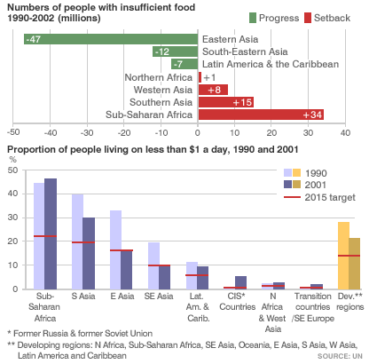

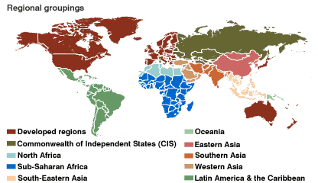

Education

Over 115 million children still receive no formal education during their formative years.

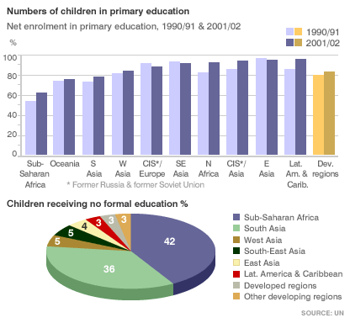

Gender Equality

Women’s rights remain a major problem in many countries and only 16% of all parliamentarians in developing countries are female.

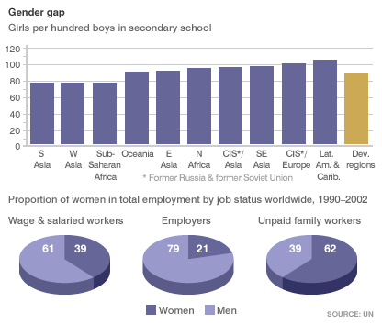

Child Mortality

At least 3 million children die each year from preventable and treatable diseases.

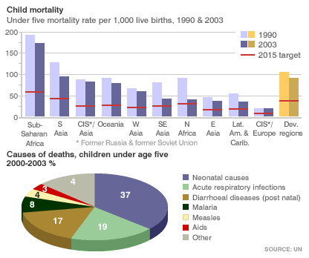

Maternal Deaths

Over half a million women die during child birth each year and many more are left permanently damaged by problems incurred during birth.

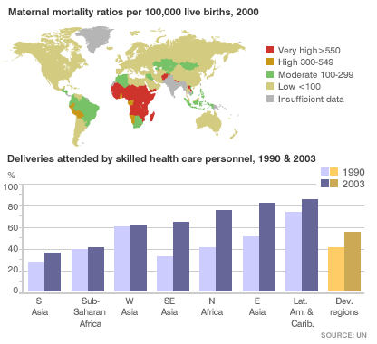

Combat Diseases

Nearly 40 million people are thought to be HIV/Aids positive and the misery caused by this affects three generations. These are those who suffer the disease, the offspring and the older generation left to look after those without parents.
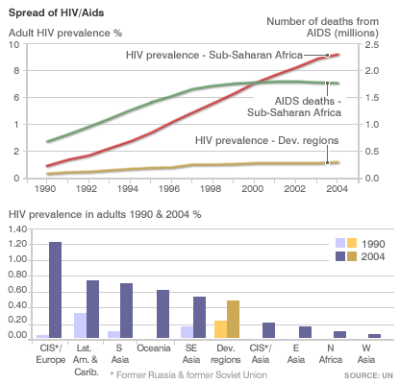

Environment

Sustainable Development can only be achieved by careful management of resources and this seldom seems to be taking place.

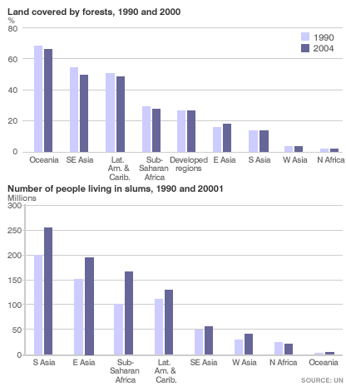

Some useful sites

The World Health Organisation (WHO)

http://www.who.int/hac/en/

Medecins Sans Frontière

http://www.msf.org/

Extension Materials

The first part of a four part series that will build into a brief economic history of the post second world war period.

Part 1 - Where did it all begin?
Let's begin by taking our analysis back to a dawning of the age when the wars in both Europe and the Far East had been brought to an end. The latter had seen President Truman decide to use the atomic forces at his disposal, so coupled with the joy of peace was an awareness that a power had been unleashed that might come to haunt us all. With peace came a re-alignment of the world's nations into three distinct groups. These were:
- the so-called 'free world' which consisted of the USA, most of Western Europe and Japan
- the Soviet Union and its satellite states in eastern Europe
- what was to be come known as the developing or Third World
It is interesting to reflect just where each stood on the eve of the millennium. The first had long abandoned the quest for full employment, which had been seen as the principal way of destroying the evils of mass poverty so familiar in pre war Europe. The second had also failed to deliver the promised increases in the economic security of the lives of the masses and the last had seen its standards of living continually fall since gaining independence from its colonial masters.
To this must be added another underlying trend, namely the loss in the belief that government could cure the problems of economic systems. In the 1990s we saw privatisation, deregulation and economic liberalism in what we know as the 'West'. The institutions founded in those far off days of Bretton Woods (the conference that took place in 1944 in New Hampshire, US, at which the Allied powers planned for post-war economic reconstruction) and therefore based on a more interventionist approach, decided that market forces were the best way of solving the problems of distribution. Into the frame of international language crept the term 'globalisation' and as we all now appreciate this was to further change the status quo that developed in the 1950s and 60s.
In the Far East the economic miracle of the period post 1945 was rudely shattered by the crashes of the late 1990s. Elsewhere, Russia, the largest of the post Soviet Union states defaulted on its loans from the west. Now all eyes are turned to China and its desire to be a major economic power by 2020.
Yet as we begin our brief look at the last 50 years it is worth noting the following:
- despite all the news that crosses our TV screens we in Europe have only seen one major conflict since 1945 and that was in the Balkans, so long the breeding ground of many of Europe's disagreements
- the world's output is greater than it has ever been and average life spans are higher for most that at any time in recorded history
- infant mortality is lower in all regions, with the exception of parts of the developing world
But, inequality is greater, poverty is more widespread and to this we have the widely believed problems of global warming and environmental degradation. This issue of culture and whether multi-cultural societies can evolve is a topic for another time and place.
We must now look in more detail at how the so-called free world managed its affairs in the post war period.

The quest for sustained wealth
With war over the search for a lasting peace began. In Britain this was combined with a genuine desire to find a better way of running society. The Conservatives and their wartime leader Churchill were defeated and the little known Labour leader Atlee was installed in Downing Street. Like Churchill, he also appreciated the need for a secure framework from which to combat the growing threat of the Soviet Union and its newly acquired empire. Peace has cost millions of lives and a considerable proportion of the wealth of Britain. However, another significant change had occurred, namely the beginning of the end of the British Empire. The leaders of the US had already fought one war to rid their own land of imperialists and they were not prepared to allow the British and French to simply return to where they had been in 1939. (Some of you may like to read more on the expansion of the US and the treatment by the Americans of Indians, Negroes and Mexican Spanish. It assists in understanding some of the American psyche.) India was the first to be returned and by the mid 1960's over half of all African territories had gained their independence. Many of those who argued against a return to colonialism also supported the creation of new economic order based on expansion, monetary stability and liberal trade principles. Such moves had their opponents, especially in Europe, where a fear of mass unemployment and its effect on the wider acceptance of Communism led to some thinking that protectionism was the best way forward. In the space of just three years Marshall introduced his huge inflow of funds to mainland Europe, currencies were re-aligned and by the early fifties, even with the threat of Korea, the 'West' was enjoying very low levels of unemployment and ever increasing growth rates. Some have described this as merely the re-building phase after a hideous conflict but for those who embraced the new convenience age the world was an exciting place in which to live.
In economics one man stood out above others at this time and he was British. His name was John Maynard Keynes (who had died in 1946) and his main ambition had been to discover a way of running an economy at or near full employment – though he was not successful in persuading the US to accept a world currency and an international bank charged with the responsibility of settling trade deficits and surpluses. However, his plan for stimulating demand within an economy by injections of money through increased government spending was adopted by most democratic administrations. To this brave new concept the British added the welfare state. It was not quite the utopia that the left had dreamed of but in the UK health and social welfare were now universally available to each according to their needs and not their means. In most economies parts of the main industrial sectors were taken into public ownership and many of the practices so repugnant to the workers of the 1920s and 30's were finally laid to rest.
A brief look across Europe sees similar systems being put in place but with national characteristics colouring their social and economic mix. In France a more centralised planning procedure was incorporated in the Monnet Plan of 1946, whilst in West Germany a mixed approach to economic management resulted in what has become known as the 'economic miracle'. With the exception of Britain the restored economies of Western Europe all grew rich on external trade. The British uniquely had a trade balance dominated by domestic demand. Whichever route was taken the 'free world' recorded some notable victories and by the mid 1970s they all showed a high degree of:
- rapid and sustained economic growth
- long term stability of the business cycle
- very low unemployment
and, although British growth rates seldom reached the levels recorded by the other fast growing economies the first thirty years of 'peace' resulted in:
- the longest period of sustained non-conflict on mainland Europe for over two centuries
- the removal of the deep cyclical downturns that had resulted in such misery in the 1920s and 1930s
- the acceptance that governments could have noticeable influence over the macro economy and so deliver electoral promises
- the complete re-building of most of the war torn economies
- the acceptance by the US that they were the engine of economic stability and had to accept financing the deficits and surpluses of both Europe and Japan
Some commentators have also noted the development of money illusion, which led many to believe that inflation was not important if one could negotiate wage increases above the rate of price increases.
This last point is where we end the first section of this brief trip through economic time. We leave it at the eve of: stagflation, commodity prices booms, an oil crisis, a financially strained US as it fights to bring its Vietnam campaign to a satisfactory conclusion and a re-alignment in the world order of economic power. The first thirty years of peace had passed with very little obvious conflict, or had they? Did Suez go by without our leaders fully understanding its implications; had labour power grown too great and just what was happening in the Far East? We are concluding in the middle of what was my youth. It was an age of 'anything seeming to be possible'. We had created our own music, culture and heroes. Symbolically, if we take 1970 as being a pivotal year in economics it also recorded the break up of The Beatles, who too many had represented the new attitudes and values which many felt would shape the new economic order. The new generation of what emerged in the US as 'baby boomers' did subscribe to ideas that the power of capital, the inadequate distribution of wealth and the need for a re-alignment in ideological thinking would feature in the world of the 1970s. As we shall see in the next part of this all too brief analysis of economic history, many of these dreams were not to materialise.

Next Week: The 1970’s and things start to change.

