What progress is being made towards the Millennium Goals? (see last weeks Review for the precise Millennium Goals)

Poverty

Over one billion people live on less than 1US dollar a day and 800,000 have insufficient food to eat.

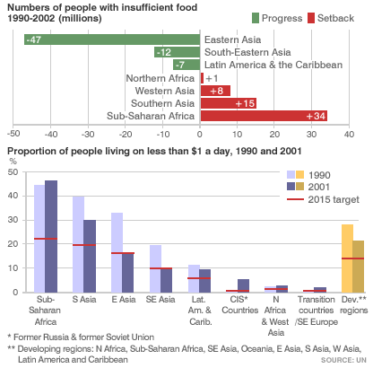

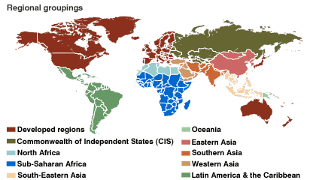

Education

Over 115 million children still receive no formal education during their formative years.

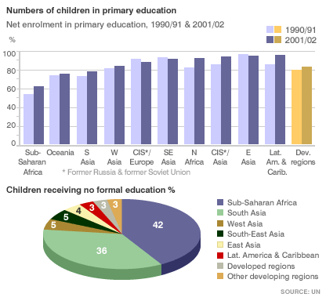

Gender Equality

Women’s rights remain a major problem in many countries and only 16% of all parliamentarians in developing countries are female.

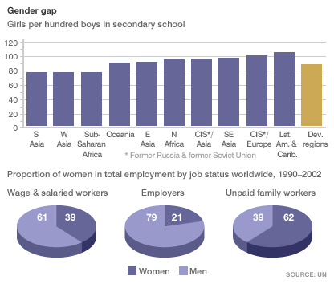

Child Mortality

At least 3 million children die each year from preventable and treatable diseases.

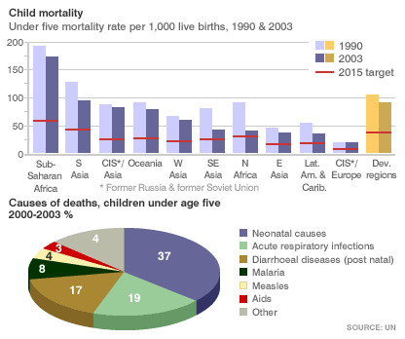

Maternal Deaths

Over half a million women die during child birth each year and many more are left permanently damaged by problems incurred during birth.

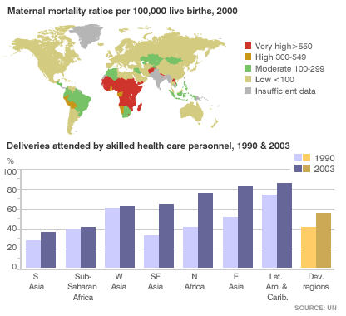

Combat Diseases

Nearly 40 million people are thought to be HIV/Aids positive and the misery caused by this affects three generations. These are those who suffer the disease, the offspring and the older generation left to look after those without parents.
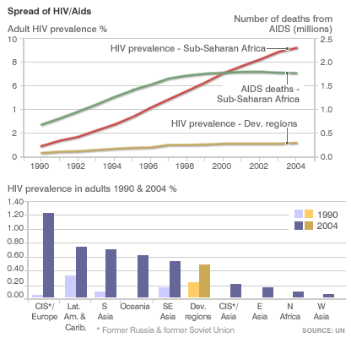

Environment

Sustainable Development can only be achieved by careful management of resources and this seldom seems to be taking place.

