World Trading Blocks

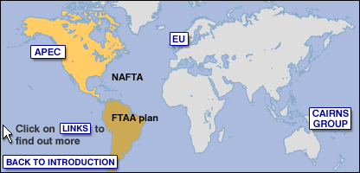

NAFTA
The United States has linked with Canada and Mexico to form a free trade zone, the North American Free Trade Agreement (NAFTA). The NAFTA agreement covers environmental and labour issues as well as trade and investment, but US unions and environmental groups argue that the safeguards are too weak. The USA hopes to expand the area to the rest of Latin America creating a Free Trade Area of the Americas (FTAA) by 2005, but key countries like Brazil are sceptical of its benefits. The US is separately signing free trade agreements with Chile and the five Central American countries of Honduras, Nicaragua, El Salvador, Panama, and Costa Rica. Meanwhile, the regional free trade pact called Mercosur, between Brazil, Argentina, Uruguay, and Paraguay, has been put under severe strain because of currency devaluation first by Brazil, then by Argentina

CAIRNS GROUP
Cairns group of agricultural exporting nations was formed in 1986 to lobby at the last round of world trade talks in order to free up trade in agricultural products. It is named after the town in Australia where the first meeting took place. Highly efficient agricultural producers, including those in both developed and developing countries, want to ensure that their products are not excluded from markets in Europe and Asia. Canada, Brazil and Argentina are other leading members. Recently key developing country members like Brazil, India and China appear to be working towards forming a separate negotiating group.
APEC
The Asia-Pacific Economic Cooperation forum is a loose grouping of the countries bordering the Pacific Ocean who have pledged to facilitate free trade. Its 21 members range from China and Russia to the United States, Japan and Australia, and account for 45% of world trade. Progress on free trade initiatives was seriously dented by the 1997-98 Asian Crisis, which hurt the economies of the fast-growing newly industrialised countries like South Korea and Indonesia, and the SARS epidemic of 2003. But recently China suggested it would be interested in establishing a free-trade zone with the growing economies of South-east Asia.

THE EUROPEN UNION
The EU has become the most powerful trading bloc in the world with a GDP nearly as large as that of the United States.The creation of the euro as a single currency for 12 EU members has led to ever closer economic links, but currently its biggest economy, Germany, has gone into recession. The EU is also facing the prospect of integrating the 10 new members from the poorer regions of Eastern Europe, who joined in May 2004, into its economic system. The EU has found it difficult to shed its protectionist past based on the idea of self-sufficiency in agriculture which limits agricultural exports from the other countries, but will implement a major reform of its Common Agricultural Policy in January 2005.

