THE EU AND ITS FINANCES

INTRODUCTION

In 2005 the European Union is expected to spend 106.3bn euros, or 1% of its members' gross national income.
The vast majority will be spent on aid to farmers and rural development (46%) and on aid to poorer regions (30%).

The EU budget is a complicated document, with separate headings for money that will be spent, and money that is committed but could be spent in future years. Here, we concentrate on money that will be spent.

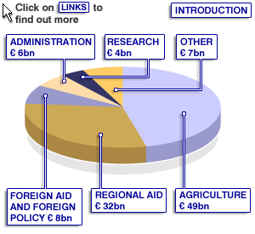

AGRICULTURE/RURAL AID

Agricultural subsidies and rural development projects swallow 46% of the 2005 budget.
France has traditionally been far and away the biggest recipients of these funds, as the bar chart below demonstrates.

Farmers from the 10 states that joined in 2004 began by receiving subsidies at 25% of the rate they are paid to farmers in the other 15 EU countries. That rate rose to 30% in 2005. Equality will be attained by 2013.

As a rule, agriculture plays a bigger role in the economies of the new member states than it does in the more developed economies of the older member states. They will in time become major recipients of agricultural and rural aid.

However, the EU is under pressure to reduce agricultural subsidies in order to give developing countries a better chance to export food to Europe.

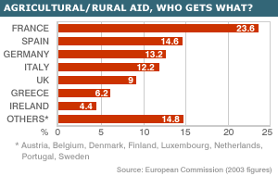

REGIONAL AID

Regional aid is the second biggest item in the EU budget, accounting for 30% of the total in 2005.
Most of it is used to boost the economies of poor, remote or under-populated parts of the European Union.

Spain has traditionally been the biggest recipient of these funds, as can be seen in the chart below (for 2003 – the latest year for which figures are available). Regional aid to Germany and Italy goes to poorer regions – the former East Germany, and the Italian south.

The accession of 10 new states in 2004 has led to a sharp fall in the average wealth of EU countries. A competition for regional aid is now likely to take place, in which Spain will struggle to retain its share of the pie.

Only two of the older EU states, Portugal and Greece, remain poorer than the EU average. Portugal's regional aid grant in 2003 was equivalent to 2.9% of the country's gross national income.

FOREIGN AID

A large slice of the European Union's foreign aid goes to future EU members. In 2005, recipients of this pre-accession aid include Bulgaria and Romania (1.3bn euros), Turkey (323m euros) and Croatia (105m).
A sum of 120m euros has been earmarked for the Turkish Cypriot community.

The EU is now the world's largest aid donor. More than 1.5bn euros is available to spend on development and humanitarian aid. Some 200m euros will be devoted to reconstruction in Iraq.

A total of 3.1bn euros will fund co-operation programmes with countries in the Mediterranean region and the Middle East, the Western Balkans, Eastern Europe, the Caucasus and Central Asia, and developing countries in Asia and Latin America.

There is a funding strategy for each region. For example, in the case of the Western Balkans the emphasis is on improving governance and fighting organised crime.

The Common Foreign and Security Policy budget funds, among other things, police missions in Bosnia and Herzegovina and in the Former Yugoslav Republic of Macedonia.
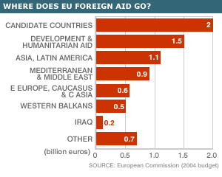

OTHER SPENDING

This includes 1.3bn euros in compensation to new member states that would otherwise have been net creditors to the EU.
About 1bn euros is earmarked in 2005 for development of trans-European transport, energy and telecoms networks.

Another 0.9bn Euros is devoted to education and culture - some of this pays for students to study in another EU state.

RESEARCH

The European Union’s spending on research and technical innovation dates back to the mid-1980s, when the US and Japan were seen recovering quickly from the post-1979 recession.

This was attributed partly to their adoption of new technology.

A simultaneous net outflow of investment funds from Western Europe to the US raised fears that the EU could be left with an obsolete industrial base.

EU research funding gives priority to projects that bring together research centres, companies and universities from different member states.

ADMINISTRATION

The administration budget covers salaries, pensions, buildings and equipment. It is roughly equivalent to the budget of the mayor of Paris.
The European Commission itself accounts for roughly half of the total - about 1bn euros less than the budget of the mayor of London.

In 2004, the EU institutions employed about 33,000 officials, of whom about 22,000 worked for the Commission. The figure is rising by 1,250 in 2005 as a result of enlargement.

Commission staff is guaranteed a job for life, with perks such as allowances for living abroad, children's education and travel home.

The financial perspective of the EU

The European Union’s financial perspective is a seven-year framework for EU spending. It sets a ceiling on the amount the EU can spend in each of its policy areas, in any of these years.
The idea was introduced in the late 1980s, in order to end regular rows over the annual budget for the following year.

The EU still has to agree an annual budget, which determines precise levels of spending, but it helps to have broad parameters fixed in advance.

The actual budget never reaches than the maximum permitted under the financial perspective, though ceilings set for particular headings can sometimes be broken by re-allocating funds from other parts of the budget.

The perspective is adopted by a unanimous decision of EU heads of state and government, on the basis of a proposal from the European Commission. It then needs the approval of the European Parliament.

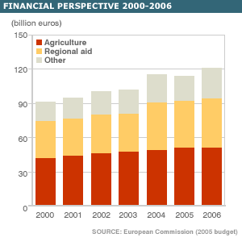

THE UK’S REBATE

The UK won a rebate from the EU in 1984 because it got a bad deal under rules determining how much countries pay into the EU, and how much they get out.
This was mainly because the UK has a relatively small farming sector, and gets a small share of EU farming subsidies. In 1984 the UK was the third-poorest of the 10 EU states, but was on course to become the biggest net contributor.

The rebate refunds to the UK two-thirds of its net contribution. All the other states pick up the bill, in proportion to the size of their economies - though Austria, Germany, the Netherlands and Sweden are excused all but a quarter of their share.

Now that the UK is one of the richest of 25 member states, all the others think the rebate should be abolished. This would have made it the biggest net contributor in 2003.

The UK says the rebate is still "fully justified" and wants big cuts in spending on agriculture and regional aid before agreeing to any alternative.

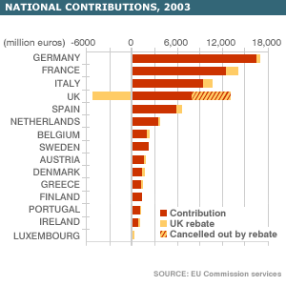

The rich and poor of European Union

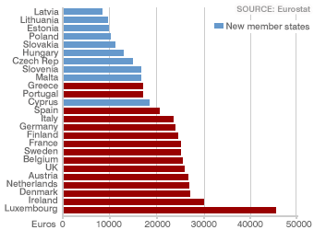

Unemployment

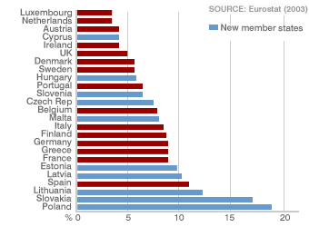

Growth Rates

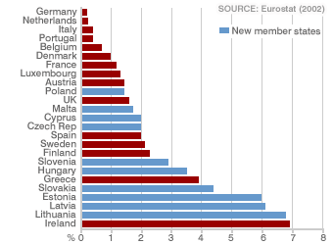

Taxes

