The 2 new member States

Romania – Some relevant facts

Romania has a population of about 22 million. This represents a drop of some 1.5m since 1990 - however, some experts say these figures underestimated the number of Romanians who have gone to live and work abroad, which is sometimes put at two million. More than 54% of the population live in urban areas. Those living in rural areas often work hard to enjoy a minimal standard of living. In 1990, all farming land was collective property - agricultural co-operatives or state farms. The end of communism allowed a large number of former owners to get back up to 10 hectares of their land - creating almost four million small private farms.
In 2005, some 22% of Romanians, including about 80% of Roma (which make up about 2.5% of the total population), lived below the poverty line The north-eastern region had the highest poverty rate, Bucharest the lowest
In 2006, the infant mortality rate per 1,000 live births was 25.5 - one of the highest in Europe.
The child welfare system, a legacy of the Ceausescu regime, was a serious problem until the end of the 1990s. But the number of children abandoned at hospitals decreased by 50% between 2003 and 2005. Further efforts to improve child welfare laws were made in 2005.
Some economic data on Romania
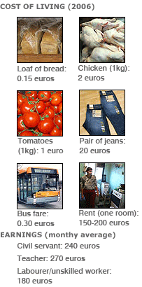

Demographics
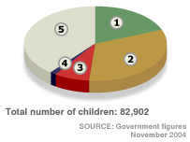
1 - Foster care (15,682)
2 - Extended family (26,928)
3 - With other persons (6,094)
4 - About to be adopted (1,225)
5 - Still in institutions (32,974)

The European Commission has praised Romania's progress in tackling human trafficking, improving detention conditions and child protection. But it says limited progress has been made regarding the treatment of people with disabilities and the integration of minorities.
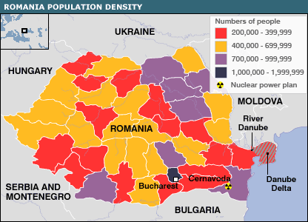
The economy
Romania's average 5.8% annual economic growth over the past five years makes it one of Europe's fastest-growing economies.

In Bucharest and the west of country, unemployment has dropped to about 2%. There were even concerns about a lack of available labour when foreign companies such as Procter and Gamble set up production plants.
Trade Statistics
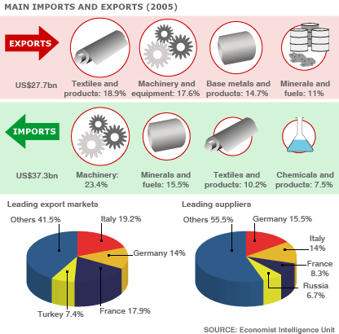

But economic growth has not alleviated widespread poverty, and corruption and bureaucracy is still said to hinder business activities. Observers say the unemployment rate is kept unrealistically low in part by emigration of Romanians in search of employment. It is estimated that between 600,000 and two million Romanians have gone to live and work abroad since 1989.

Romania was historically a major agricultural producer - but the sector is now weak. According to the US Library of Congress, agriculture accounted for more than 30% of total employment in Romania in 2004 and contributed only 10% of GDP.
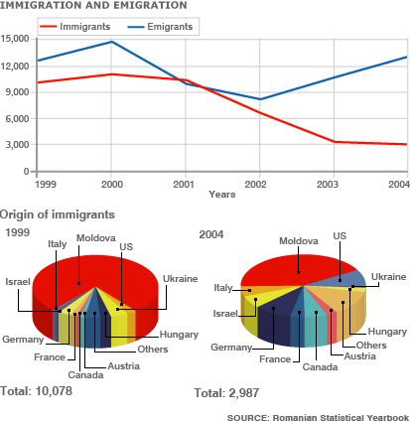

Romania’s neighbours
