The European Parliament – a brief guide

Parliament's powers
The parliament amends, approves or rejects EU laws, together with the Council of Ministers.
The process of "co-decision" - by which a law is only passed when approved by both bodies - applies in areas including consumer protection, the single market, workers' rights, asylum and immigration, the environment and animal welfare, but not foreign policy or agriculture.
The parliament also shares authority over the EU budget with the Council of Ministers and supervises other EU institutions, including the Commission. It vets new commissioners, and can sack the commission en masse.

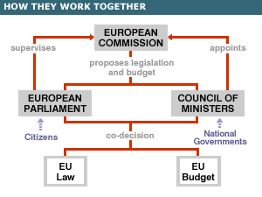

Locations
The parliament has two chambers - one in Brussels, the other in Strasbourg - and a secretariat in Luxembourg.
For three weeks of the month the parliament operates in Brussels, where most committee and political group meetings take place, then for one week it decamps to Strasbourg.
This perpetual movement adds to the cost of running the parliament, and is unpopular with members of the European Parliament (MEPs), because of the extra travel involved.
However, the Strasbourg parliament is a matter of national prestige for France. Situated on the border between Germany and France, which fought two world wars in the last century, it is also a symbol of Europe's peaceful new order.

Party groups
Most MEPs belong to one of the parliament's political groups. None has an overall majority, so amendments need the support of more than one group to get through. On most issues the parliament divides along classic left-right lines.

A group must have at least 19 members, from at least five member states. The larger the group, the more funding it receives the more key committee posts it gets and the longer it can speak in debates.
Some groups are broad churches: the EPP-ED includes euro-enthusiast Christian Democrats and euro sceptic British Conservatives while the UEN includes the moderate Irish Fianna Fail party and Italy's post-fascist National Alliance.

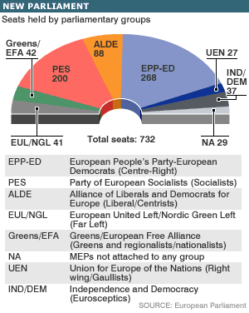

Enlargement
Before enlargement on 1 May 2004 the parliament had 626 seats. The new parliament elected in June 2004 has 732, and it will grow again when Bulgaria and Romania join, possibly in 2007.
As 162 new MEPs from new member states have taken their seats, most of the older member states have lost a few members of parliament - Germany avoided this fate because it had the fewest seats per head of population.
Enlargement puts huge new burdens on the parliament's translation service, which must now provide simultaneous translation of all debates into 20 languages.
This amounts to 190 different language combinations - Finnish-Czech, German-Portuguese, and English-Maltese and so on.
From now on, more translations will take place through a third language, such as English or French.

