TripleALearning Weekly News Letter – Edition 1

Welcome to what we hope you will find a both useful source of information for your teaching and another way of preparing your students for their examinations.
Each week we will provide:
- A current article on the UK economy or business world with questions. This can be used for class tests etc. Wherever possible we will follow the Specification delivery practiced by the majority of centres.
- An article on the EU and relevant questions attached. This will probably be of more use with your A2 students.
- A global article and questions.
- An examination question relevant to the UK article theme complete with suggested mark scheme

The UK Economy and Business World

Da Vinci boosts Eurostar tickets

The Da Vinci Code has inspired passengers to use Eurostar the train service has seen record sales for the first six months of 2006, boosted by fans of the Da Vinci Code film and World Cup supporters. Sales reached £259.9m ($478m), a rise of 6% from 2005, further helped by a sharp increase in business tickets.
Eurostar's connection to European rail networks helped the firm benefit from football fans visiting the World Cup. A sponsorship tie-up with the release of the Da Vinci Code film also helped boost ticket sales.

Eurostar said the partnership with the movie - whose cast included French actress Audrey Tatou - helped generate "strong interest in overseas markets", with travel agents reporting increased sales on the London-Paris route.

In addition, greater punctuality as well as convenience has helped Eurostar entice business customers, whose numbers rose by 11% over the period.

"Punctuality, which is now at 91%, means Eurostar continues to outperform the airlines operating on London-Paris and London-Brussels routes by a considerable margin," said the firm.

Questions

- Outline the factors that have caused the increase in the use of Eurostar.
- In what ways might to improvement in train punctuality have increased demand for Eurostar?
- Why might the Da Vinci code film have helped Eurostar

The EU Budget is finally passed

After many hours of negotiations the European Union has a new budget. It will run from 2007 until 2013. The final details of the budget were agreed in Brussels at a Council of Ministers (Heads of State) meeting in late December 2005. The agreed figures are as follows:

UK rebate down 10.5bn from a total of 50-55bn

Aid to EU newcomers: 157bn (7bn more than the UK at first proposed)

Farm and rural development aid: 292bn

Justice and interior affairs: 10.2 bn

Foreign and humanitarian aid: 50bn

Administrative costs: 50.3bn

The budget
Overall budget for 2007-13 set at 862.36bn euros, or 1.045% of the EU's combined gross national income.
Britain gives up 10.5bn euros, or roughly 20% of the rebate it would have otherwise received over the seven years. The rebate is still set to rise from its current level of about 5bn, on average, over the last few years. However, it will be smaller as a proportion of the UK's net contribution to the EU budget.
The European Commission is asked to hold a "full and wide-ranging" review of all EU spending, including the Common Agricultural Policy and the British rebate, and to draw up a report in 2008/9. EU governments will be able to take decisions on all subjects covered by the review - but will also be able to wield their veto.
Development aid for poorer countries set at 157bn euros. This is 7bn euros more than the UK envisaged in its first proposal on 5 December, but less than Luxembourg proposed at the last summit in June. The rules for accessing the money are relaxed.
The farm spending budget will be 293bn euros, as agreed at an earlier summit. However, there will be no extra money for Bulgaria and Romania once they join in 2007 or 2008, so the cash will end up being shared between 27 states rather than 25.
A range of countries were offered sweeteners, of one kind or another. The Netherlands, Sweden, Germany and Austria - all big contributors to the budget - will get away with paying less than they would have. Spain's poorer regions will continue receiving development aid for longer than originally planned. Spain and Italy got extra money for research and development.
All figures are expressed in 2004 euros, and will be automatically increased in line with inflation.

Some questions

- When was the European Union formed?
- How many members does it currently have?
- Which two countries are scheduled to join in 2007?
- Where is the European Parliament located?

Where does the money go?

In 2005 the European Union is expected to spend 106.3bn euros, or 1% of its members' gross national income. The vast majority will be spent on aid to farmers and rural development (46%) and on aid to poorer regions (30%). The EU budget is a complicated document, with separate headings for money that will be spent, and money that is committed but could be spent in future years. Here, we concentrate on money that will be spent.

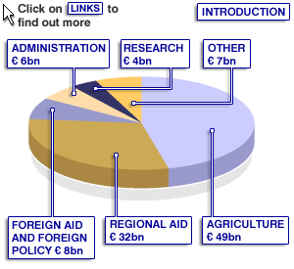

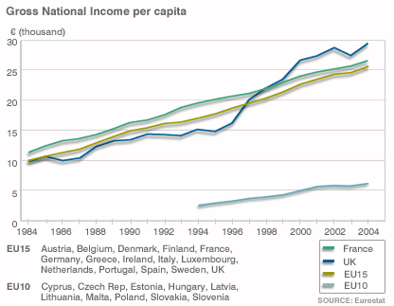

Where does the money go?

The largest proportion of the 1% of the Net National Income of member states goes to Agriculture and the Common Agricultural Policy
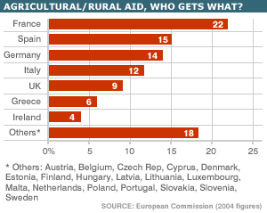

The second largest sum is spent on Regional Policy, which aims to bring all member states to a minimum of 75% of EU average income through the Cohesion and Structural programmes. By 2013 this part of EU spending should be almost equal with that of the Common Agricultural Policy.
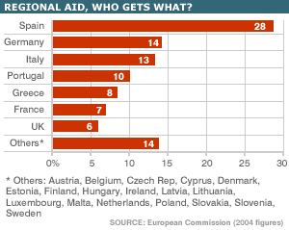
Overseas Aid
The EU is also a major donor of foreign aid and the current spending patterns are as follows:

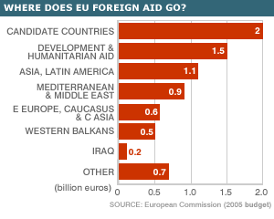
Questions

- Why did the European Union introduce price guarantees for farmers?
- What economic benefits might arise for member states if the Regional Policy is successful in its objectives?
- In what ways might the EU Overseas Aid budget be spent?

Links

You may also like to visit the following which might be of assistance with your teaching of The European Union and its workings.
Czech Republic
http://www.vlada.cz/1250/eng/aktuality.htm

The official Czech government site

http://www.praguepost.com/

An English language newspaper published in Prague.

http://www.investni.com/czech_republic.pdf#search='economy%20of%20czech%20republic'

A PDF presentation on why invest in Czech Republic.

http://www.indexmundi.com/czech_republic/economy_overview.html

The British Rebate during the last budget period

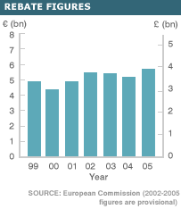

Who pays for the UK rebate?

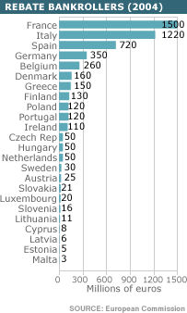

Who pays for the EU?

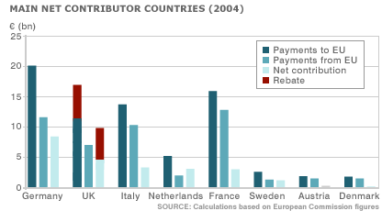

A global issue

Amazon sales fall



Online shopping giant Amazon.com has seen quarterly profits tumble, following spending on new technology and investment in its toy business. Net income fell 58% to $22m (£12m) in the three months to 30 June, from $52m a year earlier. Sales were up 22% in the quarter to $2.14bn. Amazon has increased spending, as it strives to stay ahead of rivals by offering deals such as free postage. It also has expanded its toy section after ending a tie-up with Toys R Us.
Analysts questioned the company's strategy of focusing on its discount shipping programme, Amazon Prime, at a time when it was facing intense competition and having to increase spending on technology.
The company is considering offering certain food products via its on line service.

Questions

- Why might increased spending on new technology have caused income to fall even though sales rose?
- How might competition in this huge market be benefiting consumers?
- Could the above trend lead to consolidation in this market?
- In what ways could Amazon retail food on line?

An examination style question
In this question we attempt to offer a stimulus that can be used by both AS and A2 students. You may therefore need to slightly alter or remove some questions.

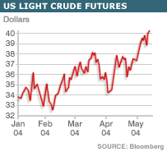

The demand and supply of oil

The perception that oil supply cannot keep up with demand has fuelled another jump in prices around the world.
London Brent crude rose another 59 cents a barrel to $37.95, while US crude futures hit $40.92, close to their all-time high of $41.15.
The trigger was oil cartel OPEC whose president effectively admitted being powerless to cool the market.

OPEC said member states were already being allowed to produce well over their quotas, but oil prices have not steadied. In fact, major oil producing countries are adding an extra 2 million barrels per day - 2.5% of worldwide demand - without having an effect on prices. The International Energy Agency (IEA) said on Wednesday that OPEC members were not pumping their full quotas. It identified 2.5 million barrels a day of spare capacity among 10 OPEC nations; roughly half of it is in Saudi Arabia.

The current strength in oil prices, which have risen by one-quarter this year alone, is partly to do with old-fashioned supply and demand.
There are supply concerns in the Middle East, where political instability is seen as a threat to oil output. The latest weekly figures show US petrol stocks fell by at least 1.5 million barrels in the last seven days, the American Petroleum Institute said. The figures will add to pressure for prices to rise.
The IEA has raised its forecast for 2004 global oil demand growth to 1.95 million barrels per day, despite generally slow growth in developed economies.

Crucially, say analysts, the traditionally close relationship between demand and supply has partially broken down: for technical reasons, a number of the world's biggest producers, particularly outside OPEC, have been unable to increase output significantly, leading to higher prices.
It seems that major buyers - especially governments - are stocking up on oil, possibly to guard against any disruptions to supply. The US strategic petroleum reserve has been a particularly active buyer, and governments such as China and India have followed suit.

Questions

- Explain why the partial breakdown in old fashioned demand a supply conditions has assisted in forcing up the price of oil. ( 10 marks)
- Why might the continued growth in demand from both China and India be a problem for oil prices in the future? ( 10 marks)
- How might increasing oil price impact on many of the poorer countries of the world? (10 marks)
- In what ways might developed countries try to promote oil efficiency within their populations? ( 20 marks)

Total 50 marks

Suggested Answers

- A clear and acceptable definition of BOTH demand and supply with relevant diagrams. (4 marks). The explanation of how demand and supply for oil has been removed from conventional theory with use of the examples given in data (6 marks).
- An awareness of the production driven Chinese economy continuing to create cheap but attractive goods for western markets and the growth in incomes allowing greater access to cars, fridges, TV’s and air conditioners will boost demand for oil. Indeed, in 2007 China will become the largest importer of oil in the world. ( 5 marks) India, which is a more service-based economy, is also increasing its demand for oil and so will Brazil – another BRIC economy. The fourth of these BRIC economies is Russia which will soon become the largest energy producer in the world. It has already shown how it can raise gas prices by restricting supply. (5 marks)
- Only a small number of developing economies e.g. Nigeria has direct access to their own oil and petrol. ( 2 marks) So most are dependent on imports, and will also have to import products that are strongly influenced by oil prices. ( 2 marks) So, they will have to put aside more foreign exchange to pay for oil imports or accept higher levels of debt. ( 2 marks) This in turn may lead to difficult opportunity cost decisions regarding oil versus say books or medical supplies. ( 2 marks) They may also experience falls in the demand for their exports as developed nations cut back on consumption as real incomes fall due to increased energy prices. ( 2 marks)
- Developed economies may have to encourage the use of cars that consume less petrol and may attempt this by: increases on taxes on petrol, increases in road taxes or less tax on lower petrol consuming vehicles. ( 6 marks) They may also look at ways of switching transport tastes towards train, coach, bus, bicycle, walking or car sharing. ( 4 marks) Domestic heating, office and factory heating schemes may have to be changed and solar, wind and other schemes encouraged via grants, subsidies and other ways (tax write-off) of making both individuals and business change their ways of generating heat, electricity and transport. Perhaps nuclear powered stations may need to be built or energy imported from other countries? (6 marks). Re-cycling waste and using this for energy generation may also have to be considered. Public awareness campaigns will be required and maybe even times at which people go to work, holiday times and even the school year. All are potential targets in the current debate. The final mark will depend on the quality of the evaluation offered.( 4 marks)

Letter from an Economist

A world in transition

The emergence of China, India and the former Communist-bloc countries means that a larger part of the earth’s population is now engaged in the global economy than at any other time in history. It is therefore essential that governments and policy makers begin to address the issues that will arise as the pace of economic change gathers increases. It is inevitable that jobs will be lost, livelihoods disrupted and policy options altered. For those charged with running our economies the challenge now is to ensure that the benefits of global economic integration are sufficiently wide spread that most people can see their lives changing for the better regardless of the problems associated with the changes that will take place. Put simply welfare economics will become more central in how policy makers across the globe address the problems of rising prices, interest rates, fiscal management and public expenditure.
Attention must be given to new technology and how this will affect trading patterns and most importantly how such changes will impact on some of the most vulnerable groups on the planet. It is unlikely that in a world of instant information the poorest members of this ‘global village’ will simply sit back and allow the old, rich countries to enjoy yet another period of unchallenged economic growth.
One of the most obvious changes that has arisen in recent years and it too has been partly driven by technology is that of the direction of capital flows. The United States and other industrialised countries are keeping interest rates low and so maintaining high consumer demand by attracting large sums of investment from the poorer countries of Asia, Latin America and the Middle East to support their trade deficits. Today the world’s largest economy, the United States and is running a deficit on the current account and this is substantially financed by capital exports from developing countries. Is this, as some believe the market working to use a surplus in one part of the global economy to finance a deficit elsewhere within its midst or is it a potential recipe for disaster as some developing economies may soon start to use their savings for their own investment? Those who fear that this trend cannot last point to the aging populations of the developing countries, the slowing down in the so-called savings glut and the appetite for capital that will surely increase as more developing economies seek to use domestic funds to boost investment.
One thing can be agreed upon by all observers and that is that the pace of global economic change is faster that at any other time in recorded history. China and other BRIC countries are changing the ways in which nation’s trade faster than in any previous period of economic advancement.
The patterns of global trade and finance have changed as well and the distinction between the ‘core’ rich countries that exported manufacturing goods and poorer ‘periphery’ countries that exported natural resources has broken down.
Production is becoming more geographically fragmented and this is across the full spectrum of production. An example is advanced micro devices many of which are produced in Texas but receive their final processing as places such as Thailand, Singapore, Malaysia and China.
As economists we have to ask how long this flow of capital from the developing to the developed world will last and what will replace it when the new nations develop more sophisticated forms of domestic capital markets. The power of capital is beginning to see some new faces amongst its once settled range of participants and many of the older members may have to change their ways in the fairly near future.

John Birchall

john_birchall@bsc.biblio.net

