Triple A Weekly News Letter – edition 2
The UK Economy and Business Environment

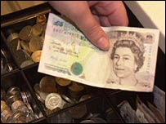

UK Inflation rises

UK inflation accelerated to 2.5% in August, the fourth month in a row it has topped the government's 2% target.
August's 2.5% Consumer Prices Index (CPI) figure from the Office for National Statistics was a slight increase on July's 2.4% level. Meanwhile, the headline RPI rate - which includes mortgage interest payments - rose to 3.4% from 3.3%.
The latest figures will renew pressure on the Bank of England to raise interest rates, analysts said. The Bank of England last increased interest rates by a quarter of a percentage point to 4.75% in August. With the Bank's Monetary Policy Committee voting 6-1 to keep rates on hold in August, some analysts now expect a further rise in November.
The Office for National Statistics said an increase in the price of computer games and toys in August had outweighed a decline in petrol prices and air fares.

Questions

- Distinguish between the Consumer Price Index and the Retail Price Index
- In what ways might this sustained increase in prices affect UK business?
- How might the government attempt to reduce inflationary trends in UK?

The EU



The world's biggest online retailer of independent music has opened a European store offering unrestricted downloads. eMusic is the second most successful download site in the US after Apple's iTunes Music Store, and will sell tracks from 8,500 independent labels. The subscription-based site will offer MP3 recordings that work on all digital music players, including Apple's iPod. But eMusic has not struck deals with major record labels, who say their music must carry digital restrictions. eMusic plans to sell music across Europe, and has employed music journalists to help confused customers navigate their way through its varied collection.

Another embryonic download service, Spiral Frog, has recently announced deals with major record labels to distribute music for free, replacing sales revenues with money from advertisers. Mr Mulligan said eMusic and Spiral Frog were part of a growing trend in the music industry away from the fixed price model pioneered by Apple.

.
Questions

- Why has eMusic decided to enter this market?
- In what ways is eMusic trying to add value to the customer perception of their product?
- Might such new ways of listening to music cause the death of the CD?

EU

The European Parliament

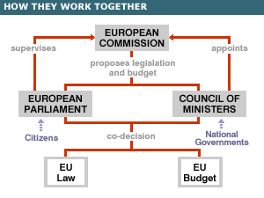

The parliament amends, approves or rejects EU laws, together with the Council of Ministers. The process of "co-decision" - by which a law is only passed when approved by both bodies - applies in areas including consumer protection, the single market, workers' rights, asylum and immigration, the environment and animal welfare, but not foreign policy or agriculture. The parliament also shares authority over the EU budget with the Council of Ministers and supervises other EU institutions, including the Commission. It vets new commissioners, and can sack the commission en masse.

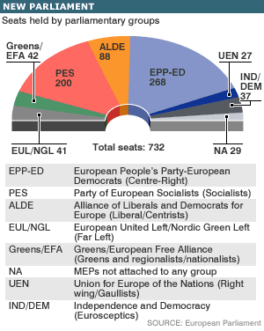

The Parliament sits in political groups which are currently as above. Note that the UK Conservative Party is considering a move away from the EPP-ED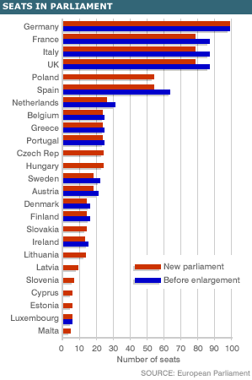

The seats in the new Parliament do not represent an exact indication of the population size and economic wealth of the individual member states. As you will see some of the larger countries have lost seats in favour of the smaller nations.

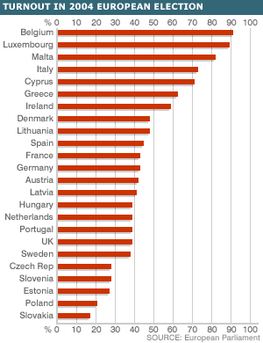

Voting in European Parliament elections is not as high as many in Brussels would wish to see. To be fair is some of those scoring a low turnout the instruments of democracy are new to the population.

Some important phrases/definitions

Qualified majority voting

The Council of Ministers has two ways of taking decisions - unanimity, when everyone has to be in agreement - and qualified majority voting - a system of weighted votes.
QMV is the most common method of decision-making, used in all but the most sensitive issues.

Issues which are decided on by QMV are also voted on by the European Parliament. This means that the council and parliament act together in co-decision.

Acquis communautaire

The entire body of European laws is known as the acquis communautaire.
This includes all the treaties, regulations and directives passed by the European institutions as well as judgements laid down by the Court of Justice.

The term is most often used in connection with preparations by the candidate countries who want to join the union.

They must adopt, implement and enforce all the acquis to be allowed to join the EU.

As well as changing national laws, this often means they must set up or change the necessary administrative or judicial bodies which oversee the legislation.

For enlargement negotiations, the acquis have been divided into 35 chapters, each of which must be 'closed' by the candidates.

Next Week – Another EU topic

An examination style question, complete with outline answer scheme

The cyclical patterns of the UK economy
For most analysts the stability of the UK economy has, over recent years been the reason that we have not undergone a period of ‘boom and bust’ economics that arose so often in the 1970’s and 80’s.
Inflation has been held within 1 per cent either side of 2 to 2.5 per cent, demand and output have grown without interruption, and employment has increased from 25.5m to almost 29m – the largest recorded working population since record began.
We are living through what is sometimes known as Nice (non-inflationary, consistently expansionary) which are taken by the Bank of England to be the result of their careful stewardship of the economy. The first-time house buyer of today would be startled to discover that rates were once 12% but will economic Niceness last for ever? But could the days of ‘boom and bust’ ever return?
It’s controversial but many of those who commented on the 1970’s and 80’s felt that a lack of monetary discipline caused the problems we associated with that era.
The cycle often started with a cut in interest rates or a relaxation of credit restrictions which encouraged banks and building societies to lend more, with much of the extra credit financing house purchase. When banks increase their loans, they also expand their deposits. Deposits are money that can be spent an indefinitely large number of times in the future.
Records show that low interest rates and credit relaxation in late 1971, mid-1977 or late 1985 were followed by rapid growth of bank deposits in 1972, 1978 and 1986.
The governments of the day relied on money discipline to regulate inflationary pressures and the former ways of demand management were put back into the history books. Alas, inflation continued and so other policies were added to the armoury. These included the much talked about ‘supply-siders’, the use of the exchange rate to allow export and import prices to be adjusted in the favour of what was thought best for the UK economy and after much discussion the return of demand management, or ‘fiscal stance’ as it came to be known.
To those new to economics we now have the characteristics outlined in the opening paragraph but for how long? Here the story gets less clear. Are we living on borrowed time with low interest rates fuelling consumer spending, a continued housing boom and a false feeling that all is perfect? For some this scenario fails to note mounting personal debt, rising prices, increasing trade deficits and even an upward movement in unemployment.
A growing number of observers are worried that the days of ‘boom and bust’ may yet re-appear and that the medicine needed to cure such a complaint may be very difficult for the UK public to swallow.

Questions

- Explain what is meant by the term ‘boom and bust’ ( 5 marks)
- Analyse the ways in which successive governments have ‘managed the UK economy’ ( 15 marks)
- Why does the UK economy tend to suffer from cyclical movements? (20 marks)

Answers

1. The periods through which an economy can pass when it moves through times of high levels of growth and employment only to reach a point when the economy cannot grow as fast without incurring inflationary pressures. These cause the economy to slow, growth to recede and employment to fall. During the 1970’s and 80’s the UK experienced sustained period of fast growth followed by a period of sometimes equally as fast falls. The former resulted in period of fast rising prices whilst the latter resulted in periods of fast rising unemployment.

2. Successive governments have used a mixture of:

- Monetary policy – you need to note role of Monetary Policy Committee since 1997 and the use of short term interest rates. This policy is designed to control consumer spending via charges for loans, mortgages and other forms of money lending. The rather unusual way in which we buy our houses means that changes in interest rates have a greater impact on both house prices and disposable income. Interest rates also affect credit card costs and this too impacts on consumer spending. Consumer spending trends and tastes greatly influence business investment and so changes in interest rates have affected another part of the National Income equation. You will need to be able to outline the accepted impact of this policy on keeping inflation initially within a +/- 1% of 2.5% target and now +/- 2.0%.
- Fiscal Policy – successive Chancellors have changed direct rates of taxation e.g. income tax and profits tax to allow a more individual determination of how income is spent or invested. By changing tax rates and budgetary stances the government has tried to smooth extremes within the economic cycle. Once again you will need to provide some evidence as to both how this achieved and in what levels of success.
- Supply-Side Policies – these tend to be more long-term but they too were not really visible when we last experienced ‘boom and bust’. You will need to explain how they are supposed to release potential within the economy for AS to respond to changes in AD and so allow the output gap to be less volatile. You will need to explain the main components of this policy heading, such as privatisation, de-regulation, greater emphasis on education and training, labour market reforms and the promotion of an entrepreneurial ethos.
- Exchange Rates – though less obvious than they once were a government could allow an upwards or downwards drift in the exchange rate and so alter the final prices of exports and imports. An appreciation in the £ leads to higher export prices and lower import prices, whilst a fall has the opposite affect.

They would probably award you 3 to 4 marks per option, depending on your ability to explain, illustrate and comment on each.

4. It’s often a good start to include a diagram on how an economy moves through cycles
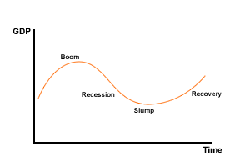
You will need to quickly explain each phase. Whilst doing this you will need to explain why the more extreme situations arise. So, note that the boom takes place when AD is moving quickly and the output gap is probably closing to the point where the AS constraint is arrived at and then is slows down. You will also need to say what will happen then, such as inflationary pressures and possible balance of payments problems.
The downturn will require you to give some attention to:

- the loss of international competitiveness as a result of inflation
- the possibility that government will introduce policies designed to cut AD, such as increases in taxes and/or interest rates.
- The fall in economic growth will push up unemployment which in turn will require government to spend more on benefits
- Business confidence and probably consumer confidence as well will fall and so prolong the downturn

You will need to briefly write about a recession – what it is, how it affects the economy and how it might ultimately be overcome.
It would then be a good time to introduce your knowledge of the two schools of thought that still dominate much of the economics of this topic

- Keynesian

Result of changes in spending and investment. A small change in spending has a knock-on effect on national income. Injection of income builds through multiplier effect and reverse. Business reacts via investment to changes in income levels. When FULL EMPLOYMENT reached government slows down economy, by fiscal and/or monetary means, so restricting AD. Investment is cut back and the downward process begins. So, changes in investment and expectations are important factors in the cyclical movement of the economy

2. Monetarist
Their interpretation is based on changes in the money supply. If money supply grows faster than output then consumption will rise as people feel better off. This extra spending leads to inflation. When this takes place consumers note a fall in their real incomes and reduce spending. Exports may fall as their price competitiveness declines.

(You may like to include the Fisher Equation, which is MV=PT = Quantity Theory of Money)

Other factors which you might include would be:

- political factors and the political cycle
- shocks – both demand-side e.g. inflation and supply-side shocks e.g. oil prices or new technology

Conclusion

You might also like to include something on:

- the behaviour of government when trying to slowdown or quicken the pace of the economy – increasing or decreasing expenditure and note that spending on benefits automatically increases during a recession, whilst government spending tends to fall and tax revenue rise during a boom.
- The 3 year spending plans of government, the golden rule principle and limits to government borrowing.

Diagrams
Always include the AD and AS diagrams that illustrate just what happens when the above is taking place.

The reward for your answer will greatly depend on the range of reasons you have given, the quality of your analysis and the relevance of your diagrams

The Global Economy

The IMF has once again called for China to re-examine the external value of its currency, however, within the organisation opinions differed as to exactly how China should proceed.

"Many directors found it appropriate for China to continue to allow greater flexibility in its exchange rate in a gradual and controlled manner," the IMF report said. "A number of other directors, however, stressed that the flexibility afforded by the current exchange rate system should be used more extensively." The United States, which has been prodding China for several years to move to a more flexible currency system, wants to see Beijing make more progress now.
The United States last year ran a trade deficit of $202 billion with China — the biggest deficit ever record with a single country. So for U.S. policymakers, the matter of Beijing's currency policies is of keen importance.
U.S. manufacturers contend that China is keeping its currency artificially low. That gives China an unfair trade advantage by making Chinese goods flowing into this country cheaper and U.S. goods flowing into China more expensive. Manufacturers and some lawmakers on Capitol Hill say the situation has hurt U.S. exports and contributed to the loss of U.S. factory jobs.
Against that backdrop, various proposals have been offered in Congress to impose high tariffs on Chinese goods unless the country changes its currency practices.
Last year, China said it would let its currency rise slightly against the dollar. The IMF, United States and others welcomed the move but stressed that more progress needed to be made.
The IMF said China, which grew by a blistering 10 percent last year, should motor ahead at around the same pace this year.
To better reflect changes in the global economy, the IMF recently proposed increasing the voting share of rapidly growing China, South Korea, Mexico and Turkey at the fund.

Questions

- Explain the main differences between a fixed and a floating exchange rate.
- Why might a country decide to allow its currency to float?
- What are the advantages Chinese exporters are gaining from the current rate of the Yuan and why are many US businesses concerned by this?

Letter from an Economist

Is the IMF too exclusive?

For many of us who monitor global economics the IMF looks to be little more than an old boys club. It is based in New York and in the opinion of many operates from a perspective that is dominated by rich, industrialised nations. It was therefore good to see that the recent executive board meeting passed a resolution allowing greater voting rights to China, South Korea, Turkey and Mexico. This reapportionment of power within such an august institution is long overdue and can only add to its credibility.
The world and its institutions have to wake up to the fact that China for example represents around 15% of world gross domestic product but until the recent changes had 2.9% voting share at the fund. Belgium, who with respect are not a major player in world trade enjoyed a 3.7% voting rights share and yet represents just 2.1% of the global economy.
With the current economic imbalances that are clearly visible within the fast growing globalisation of trade it is essential that the body designed to assist the poorest and critically assess the rich is seen as impartial and fair by those it seeks to help. Just as the continued underperformance of many of the ‘poorer’ countries hampers both their development and that of the richer producing countries so the latter’s failure to behave responsibly can reap havoc if not addressed by a respected body.
The Bush Administration, who supported these changes, hopes that with a greater say in how the IMF functions China will behave more responsibly. This will show itself by a policy that allows the yuan to strengthen against the dollar, so beginning the process of reducing the apparent permanent march of Chinese exports. Many now think that China needs a more flexible exchange rate mechanism and that if it does allow a revaluation of the yuan then other Asian countries will also let their currencies move upwards.
What will really test the authority of the IMF is it embarking on an open analysis of who is buying all these cheap exports and where is the finance coming from. China may be the enabler but as for how much longer can the US run such a large trade deficit? Some in the US point to Washington accepting both deficits on trade and budget as the price it has to pay for global economic stability whilst others suggest that both suit domestic convenience, especially this close to mid-term elections.
No, what would really herald a change in the IMF would be it suggesting to the US that it must reduce both of its deficit and the fund could also press for greater involvement it its decisions being given to the BRIC economies and others from the emerging continents of South America, Asia and Africa. If it did then not only would this allow a greater transparency to be given to its working but it might point the way fore the UN to invite more permanent members to the Security Council, so allowing it to also reflect the changes in economic influence that have merged over the last two decades.
The Annual General Meeting of the IMF will soon be up on us and we most hope that both its structure and focus will be given a new sense of direction and relevance.

