Aid v Business – a fuller picture

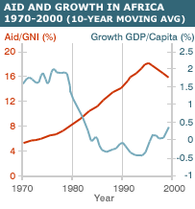

Will aid actually drive Africa into a sustained period of economic growth or will ‘business’ have to be attracted?

The pro business school of thought would suggest something along the following lines.

- Do not spend any more money on development aid
- Withdraw all aid to countries that are not pursing sound economic policies and that fail seriously to build institutions for democracy and transparency
- Countries that meet these high standards should, within a limited period of time, be assisted with 'locking-in' already accomplished reforms and, in particular, with pursuing additional reforms
- Rich countries should immediately open up their markets for exports from poor countries
Business Friendly?
A recent World Bank report praised countries in Eastern Europe for the measures they had taken to streamline business regulations and taxes.
. "From setting up a business, through dealing better with construction licenses, improving property registration, hiring new workers, to paying taxes, contract enforcement and bankruptcy and access to credit – these are the creators of jobs and that is what all countries want.
Much of the drive for reform was spurred by the integration into the European Union in May last year of 10, mostly former communist, new member states.
But while singled out as a leading reformer, Serbia and Montenegro - which is not an EU member - was ranked 92nd in the World Bank's index of the easiest places to do business.

Business risk
The Democratic Republic of Congo, Burkina Faso and the Central African Republic were ranked at the bottom of the report's Ease of Doing Business Index.
Among the emerging market economies, China was ranked at 91, Indonesia 115 and India 116.
Although ranked at 139, Rwanda was praised among African nations for making efforts to improve its business environment.
But the report highlighted Sierra Leone, where full payment of business taxes would swallow up 164% of a company's gross profit.
"Many African countries that desperately need new enterprises and jobs risk falling even further behind other countries that are simplifying regulation and making their investment climates more business friendly," Mr Klein warned.

If Aid is the answer then who gives what and how is it used?

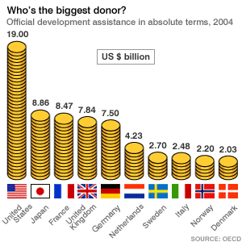

It’s the US but much of this is ‘private aid’ given by individuals and religious organisations. The Scandinavian countries normally head the list for aid that comes through central government.

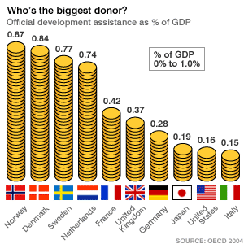

The importance of the Scandinavian can be seen if we view aid as a proportion of national income.

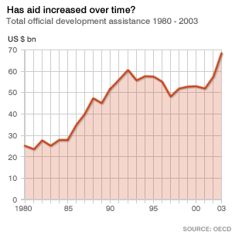

When analysing aid we also need to look at whether the amount given has been increasing in REAL terms. As you will note the last couple of years has seen a genuine increase in the amounts being given.

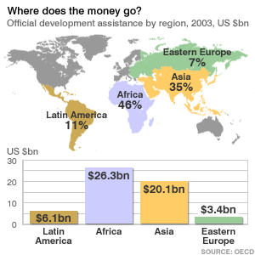

From the above document you will see that Africa is the largest recipient of aid – both bilateral and multilateral.
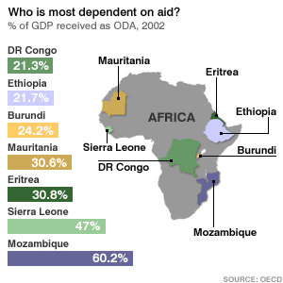

The above shows who is most dependent on aid flows and Sierra Leone for example records almost half of its GDP as coming from external aid contributions.

The question that has to be asked and especially in the aftermath of G8 and Gleneagles is will ‘business’ produce the desperately needed economic, will aid be the answer, or will government have to attract both?

