Sierra Leone in debt relief deal

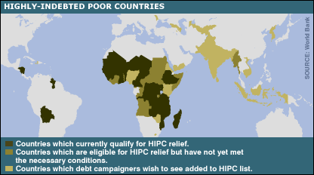

The bulk of Sierra Leone's debt will be written off after it took steps to stabilise its economy, improve governance and tackle poverty.
About 90% of the country's debt, worth about $1.6bn (£815m) will be cancelled in a series of deals with creditors including the World Bank.
The move follows last year's agreement by G8 leaders to cancel the debts of the world's most indebted countries.
Sierra Leone has been largely stable since its civil war ended in 2002.
During a visit to Sierra Leone earlier this year, World Bank boss Paul Wolfowitz praised its post-conflict recovery as the most successful in Africa.

'Milestone'

The World Bank said the debt deal was a major "milestone" for Sierra Leone, but stressed that more needed to be done to boost its economy and tackle poverty.

Sierra Leone qualified for debt relief worth $994m under the World Bank's heavily indebted poor countries (HIPC) initiative after making key reforms to the economy, government administration, health and education.

‘Sierra Leone has made good progress toward securing macroeconomic stability’

Norbert To, International Monetary Fund

Having taken these steps, the World Bank, the International Monetary Fund and other financial institutions have cancelled a further $610m in debt under the terms of a multilateral debt initiative agreed at Gleneagles in 2005.

The twin deals leave Sierra Leone with an external debt of just $110m.

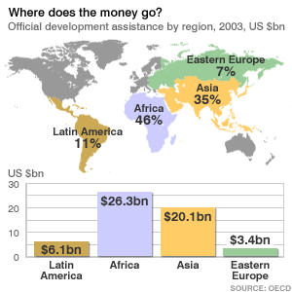

The World Bank said Sierra Leone's government was committed to ensuring that the resources made available by the debt deal would be directed to growth and anti-poverty initiatives.
Ministers were also committed to tackling waste and corruption in government and public procurement, it added.
"Sierra Leone has made good progress toward securing macroeconomic stability and established a good track record of policy implementation in 2005 and the first half of 2006," said Norbert To, the IMF's most senior official in Sierra Leone.
"Looking forward, a key challenge is to sustain high economic growth rates in order to further reduce poverty while maintaining macroeconomic stability."
The Sierra Leone government said it was committed to "ridding" the country of poverty while pursuing sustainable economic growth.

