WTO Meeting – Hong Kong December 2005.

Some of the main decisions

Agricultural subsidies: Farm export subsidies will progressively be phased out by 2013. However, there has been no agreement on import tariffs
Cotton: Rich countries will phase out export subsidies for cotton, but there is no agreement on a date for reducing domestic subsidies for US farmers
Development Aid: The poorest countries will get quota-free and duty-free access to global markets for 97% of their goods

AGRICULTURE
At the heart of the Hong Kong summit is the question of poor countries' access to rich states' agricultural markets.
Farmers in many developed states receive heavy subsidies, which makes it hard for poor country farmers - who may be more efficient - to export their goods to the biggest markets.
As well as subsidies - such as the European Union's Common Agricultural Policy or US export subsidies designed to make US farm products cheaper overseas - tariffs or quotas can block agriculture exports.
The US and the larger developing countries (G20), as well as big farming nations like Canada and Australia, want the EU to go much further than it has in reducing its subsidies and increasing market access for farm goods.
It is also unpopular for its high tariffs on bananas - which replaced its long-standing system of quotas with special preferences for imports from former colonies. Latin American banana producers believe they could export more bananas to the EU, while the former colonies worry about losing their preferences and want compensation.
But the EU says it has gone far enough, and will not make another proposal until countries move on the issues at stake in the trade round.
And the US is under fire for its generous cotton subsidies. West African producers want the US to abolish these subsidies, but the US says it will only do so as part of an overall deal on agriculture.
TRADE IN OTHER GOODS
The so-called "non-agricultural market access" issue (Nama) is all about manufactured goods, which attract relatively low tariffs in most rich countries.
They can still be quite high in some developing countries like India, but they say they will only make an offer on this issue when they get some movement on agriculture.
They are also concerned that the planned formula for tariff reductions would force them to make bigger cuts than the rich countries.
Some developing countries, like China, could also gain from this proposal which would make it easier for them to export their manufactured goods to other developing countries.
SERVICES
A key element in the trade talks is the attempt to liberalise trade in services such as telecommunications, shipping, and banking and finance. This is the fastest-growing area of trade, and one where the US and the EU are most competitive.
But these talks have stalled, since few countries have made offers to liberalise key service sectors.
They have been put on the backburner at Hong Kong. But several poorer countries now want to rewrite the draft agreement to restrict the right of rich countries to toughen up their requests for liberalisation - while businesses want the EU to get tough, so as to force countries to open some key sectors.
DEVELOPMENT PACKAGE
The EU has introduced a fourth element into the trade talks: a development package, with the explicit aim of gaining some tangible benefits for developing countries.
The EU wants other countries to adopt its plan for duty-free, tariff-free access to its markets for the world's poorest countries, the 50 least developed countries (LDCs) which together account for less than 1% of world trade.
The package also includes increased "Trade for Aid" which aims to give money to the LDCs to help them improve their trade infrastructure and compensate them for losses as a result of free trade.
The US has problems with some elements of this package, since it would mean that some big textile importers like Bangladesh would enjoy duty-free access to the US market.
But the US has signalled in principle that it is prepared to accept it, and announced an increase in its own Trade for Aid package.
Some bigger developing countries are also concerned that this plan would give an unfair advantage to the LDCs.

The major trading blocks

1. APEC
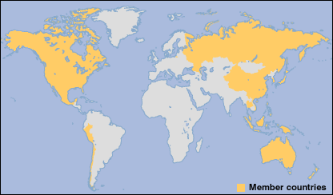

Members: Australia; Brunei; Canada; Chile; China; Hong Kong; Indonesia; Japan; South Korea; Malaysia; Mexico; New Zealand; Papua New Guinea; Peru; Philippines; Russia; Singapore; Taiwan; Thailand; United States; Vietnam
The Asia-Pacific Economic Cooperation forum is a loose grouping of the countries bordering the Pacific Ocean who have pledged to facilitate free trade.
Its 21 members range account for 45% of world trade.
They have pledged to liberalise trade among themselves by 2010 for developed countries and 2015 for developing countries.
Recently China has begun signing bilateral free trade deals with a number of APEC members.
CAIRNS Group
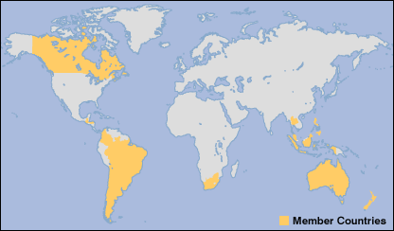

Members: Argentina; Australia; Bolivia; Brazil; Canada; Chile; Colombia; Costa Rica; Guatemala; Indonesia; Malaysia; New Zealand; Paraguay; Philippines; South Africa; Thailand; Uruguay
The Cairns group of agricultural exporting nations was formed in 1986 to lobby at the last round of world trade talks in order to free up trade in agricultural products.
It is named after the town in Australia where the first meeting took place.
Highly efficient agricultural producers, including those in both developed and developing countries, want to ensure that their products are not excluded from markets in Europe and Asia.
The developing country members of this group have now formed their own grouping, the G20.

European Union

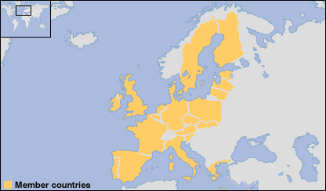

Members: Austria: Belgium: Cyprus; Czech Republic; Denmark; Estonia; Finland; France; Germany; Greece; Hungary; Ireland; Italy; Latvia; Lithuania; Luxembourg; Malta; Netherlands; Poland; Portugal; Slovakia; Slovenia; Spain; Sweden; United Kingdom
The EU has become the most powerful trading bloc in the world with a GDP nearly as large as that of the United States.
It is also the largest importer of agricultural products from developing countries, and maintains close links to its former colonies in the ACP group through trade preferences and aid deals.
The EU has found it difficult to shed its protectionist past based on the idea of self-sufficiency in agriculture which limits agricultural exports from the other countries, although it has implemented a major reform of its Common Agricultural Policy to shift subsides to support the environment.

G20

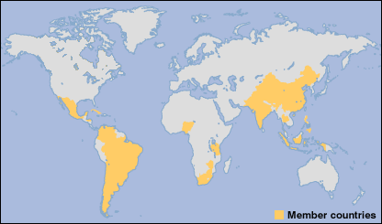

Members: Argentina, Bolivia, Brazil, Chile, China, Cuba, Egypt, Guatemala, India, Indonesia, Mexico, Nigeria, Pakistan, Paraguay, Philippines, South Africa, Thailand, Tanzania, Uruguay, Venezuela, Zimbabwe
At the Cancun meeting of the world trade talks in September 2003, a powerful new grouping of developing countries emerged.
Led by rapidly growing countries and major exporters like Brazil, China, India, and South Africa, this group has been powerful enough to challenge the EU and the US in trade negotiations.
At Cancun, the G20 made it clear that it could not accept the EU plans to include investment and competition as elements in the trade talks.
Now, the G20 are standing firm in insisting that rich countries make concessions on agriculture before there will be any final agreement on services or reductions in tariffs on manufactured goods.

NAFTA
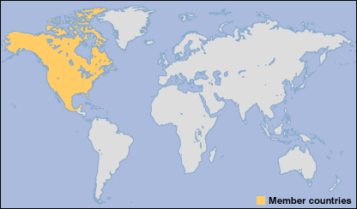
Members: Canada; Mexico; United States
The United States has linked with Canada and Mexico to form a free trade zone, the North American Free Trade Agreement (NAFTA).
The NAFTA agreement covers environmental and labour issues as well as trade and investment, but US unions and environmental groups argue that the safeguards are too weak.
Plans to include the rest of Latin America creating a Free Trade Area of the Americas (FTAA) have been put on hold following opposition from key countries like Brazil.
But the US is separately signing free trade agreements with some Andean Pact nations and on 1 January 2006 the Central American Free Trade Area (CAFTA) will come into effect, including Guatemala, Honduras, Nicaragua, El Salvador, Costa Rica, and Dominican Republic.
Meanwhile, the regional free trade pact called Mercosur, between Brazil, Argentina, Uruguay, and Paraguay, will be expanded to include Venezuela.

World Trade Organization
The World Trade Organization (WTO) is an international body whose purpose is to promote free trade by persuading countries to abolish import tariffs and other barriers. As such, it has become closely associated with globalisation. WTO in session in Geneva; decisions are binding on members
The WTO is the only international agency overseeing the rules of international trade. It polices free trade agreements, settles trade disputes between governments and organises trade negotiations.

WTO decisions are absolute and every member must abide by its rulings. So, when the US and the European Union are in dispute over bananas or beef, it is the WTO which acts as judge and jury. WTO members are empowered by the organisation to enforce its decisions by imposing trade sanctions against countries that have breached the rules.
Based in Geneva, the WTO was set up in 1995, replacing another international organisation known as the General Agreement on Tariffs and Trade (GATT). GATT was formed in 1948 when 23 countries signed an agreement to reduce customs tariffs. The WTO has a much broader scope than GATT. Whereas GATT regulated trade in merchandise goods, the WTO also covers trade in services, such as telecommunications and banking, and other issues such as intellectual property rights.
Membership of the WTO now stands at 149 countries. China formally joined the body in December 2001 after a 15-year battle. Russia wants admission, but must first convince the EU and US that it has reformed business practices. The highest body of the WTO is the Ministerial Conference. This meets every two years and, among other things, elects the organisation's chief executive - the director-general - and oversees the work of the General Council. The Ministerial Conference is also the setting for negotiating global trade deals, known as "trade rounds" which are aimed at reducing barriers to free trade. The General Council is in charge of the day-to-day running of the WTO and is made up of ambassadors from member states who also serve on various subsidiary and specialist committees. Among these are the Dispute Settlement Panels which rule on individual country-against-country trade disputes.

Some main facts
Founded: 1995
Members: 149 states (November 2005)
Budget: 125 million US dollars
Staff: 601
Key players: US, the EU, Japan

The big debates
The WTO has been the focal point of criticism from people who are worried about the effects of free trade and economic globalisation. Opposition to the WTO centres on four main points: Battle for Seattle: Violent protests disrupted WTO trade talks in 1999 WTO is too powerful, in that it can in effect compel sovereign states to change laws and regulations by declaring these to be in violation of free trade rules. WTO is run by the rich for the rich and does not give significant weight to the problems of developing countries. For example, rich countries have not fully opened their markets to products from poor countries. WTO is indifferent to the impact of free trade on workers' rights, child labour, the environment and health. WTO lacks democratic accountability, in that its hearings on trade disputes are closed to the public and the media. Supporters of the WTO argue that it is democratic, in that its rules were written by its member states, many of whom are democracies, who also select its leadership. They also argue that, by expanding world trade, the WTO in fact helps to raise living standards around the world.

