Economic Report (4)

GEOLOGY

Most of Sierra Leone is underlain by rocks of Precambrian age (Archaean and
Proterozoic) with a coastal strip about 50 km in width comprising marine and estuarine sediments of Tertiary and Quaternary to Recent age. The Precambrian (mainly Archaean) outcrops cover about 75% of the country and typically comprises granite-greenstone terrain. It represents parts of an ancient continental nucleus located on the edge of the West African Craton.

The Archaean basement can be subdivided into infracrustal rocks (gneisses and granitoids); supracrustal rocks (containing greenstone belts); and basic and ultrabasic igneous intrusions.
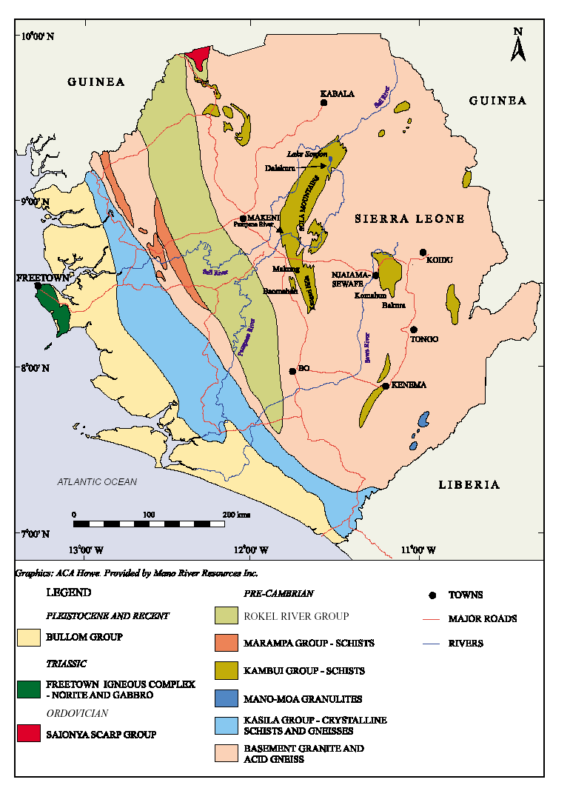
Source: Sierra Leone Mining Review February 2003

The Leonean orogenic episode commenced with the intrusion of a basic igneous suite (the Pre-Leonean amphibolites) and by the formation of a greenstone belt represented by the Loko Group which is now deeply eroded. The Loko Group comprises amphibolites, sillimanite quartzites and ironstones. It appears to have formed on a gneiss/granitoid basement in which several granitoid bodies related to an earlier plutonic-orogenic episode, have been distinguished mainly in the northern part of the country. Only the main deformational phase of the Leonean orogenic episode, which resulted in folds and fabrics trending east-west, has been distinguished. Minor gold and cassiterite mineralization associated with portions of the Loko Group is probably related to a late Leonean granitisation event which accompanied the formation of major shear zones in the craton. Other volcano-sedimentary sequences are preserved within the granites, gneisses and migmatites. Highly folded greenstone belts predominate in north and central Sierra Leone.

In the southeast the metamorphic facies increases, first with the Kambui Schists and finally with the Mano-Moa Granulites. Greenstone belts of the Kambui Supergroup are believed to have been deposited upon a post-Leonean basement and accompanied by basic to ultrabasic intrusives. The Kambui Supergroup includes most of the schist belts exposed in the Sula Mountains and the Kangari, Kambui, Nimini and Gori Hills; the Marampa Group; and the two small greenstone belts of Serekolia and Sankarama in the northeast. These greenstone belts comprise a lower volcanic unit composed of ultrabasic lavas and basic lavas with pillow layers, overlain by a sedimentary unit comprising tuffs, pelitic and psammitic sediments, with conglomerate layers and ironstone bands. The greenstone belts are the principal hosts of the gold mineralisation of the country.

Other associated mineral deposits include molybdenite, columbitetantalite and chromite. The Marampa Group, bounded on its eastern margin by a tectonic contact, is important for its iron-ore deposits and forms the upper part of the Kambui Supergroup. Late Liberian granitoids, marginal to, and within, the Kambui Supergroup, are associated with important zones of shearing and deformation where gold, sulphide and molybdenite mineralization has been concentrated.

The Rokel-Kasila Zone bounds the main part of the West African Craton on its west and southwestern margin in Sierra Leone, and appears to form part of a north-south orogenic belt. Within this belt, the Marampa Group appears to represent some of the oldest rocks. The Kasila Group, also considered to be part of the Kambui Supergroup, comprises a high-grade series of granulites, consisting of garnet, hypersthene and hornblende gneisses, quartzites and associated migmatites. Where eroded, significant secondary deposition of titanium minerals have formed from this unit. The Kasila Group also contains bauxite. A late Precambrian to Cambrian sedimentary and volcanic assemblage, the Rokel River Group, was deposited unconformably on a basement complex. Deposition was probably in a fault bounded basin of the intracratonic type along the line of the Rokel-Kasila Group following the formation of the tectonic zone at the end of the Liberian or during the Eburnean Orogeny. Dolerite intrusions are common as dykes trending mainly east-west within the basement complex, and as extensive sills above the Rokel River Group. Kimberlite dykes and pipes follow a similar pattern in the east of the country, and could also be present in the north and west. The Freetown igneous complex forms an intrusive body on the coast, with arcuate outcrop concave towards the west. It is composed of a layered complex of gabbro, norite, troctolite and anorthosite. Platinum occurs in the gravels of many of the streams that cut the outcrops of anorthosite and anorthositic gabbro in the noritic gabbro complex of the Freetown Peninsula. The relationship of this complex with the other units is obscured by the coastal veneer of Tertiary sediments of the Bullom Group which lies unconformably on the basement.Tertiary and more recent weathering has led to lateritisation across a large part of Sierra Leone, affecting mainly the greenstone belts and the extensive dolerite intrusions. The bauxite deposits formed within the Kasila Group are a result of this weathering process.

Source: Sierra Leone Mining Review February 2003

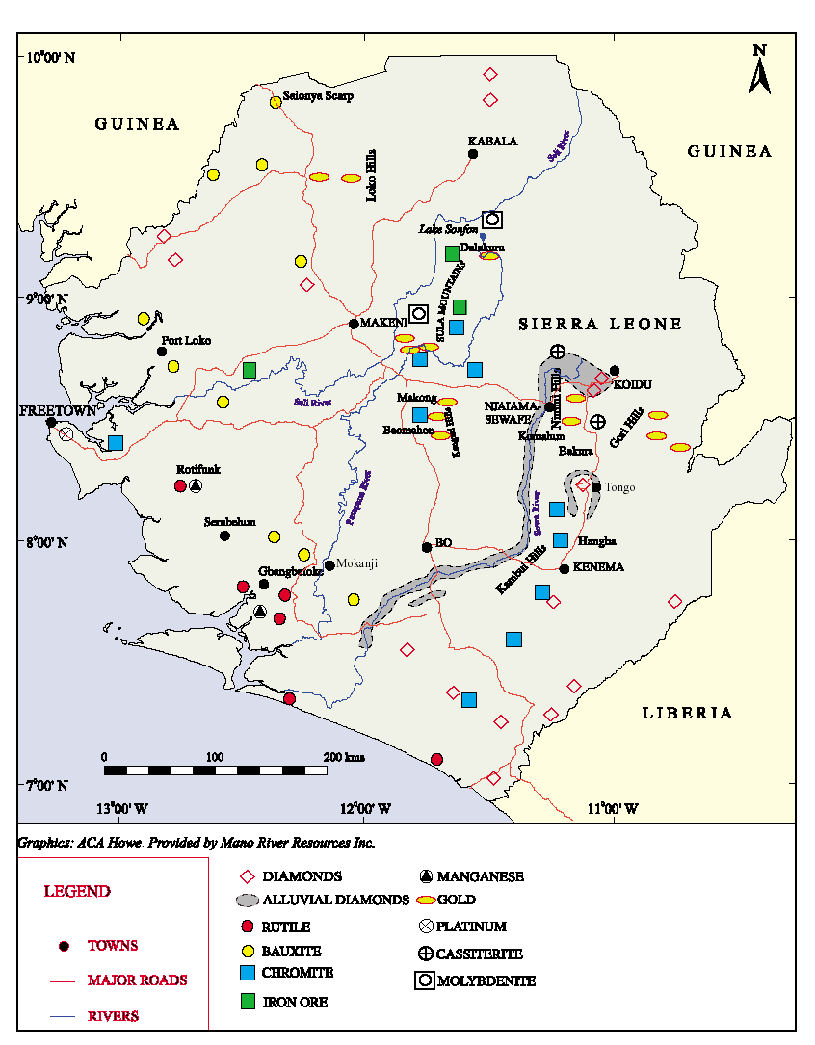
Source: Sierra Leone Mining Review February 2003
MINING INDUSTRY

Sierra Leone’s economy mainstay is its mining industry. The country has rich deposits of diamonds, iron ore, bauxite, titanium ore, gold, diamonds and chromite. The development of the country’s mining industry has been negatively affected by the eleven-year civil war. Investors have been driven away by several conflicts and economic instability. Following the return to peace in January 2001, we are now witnessing a return of foreign capital driven by rising commodity prices, a weakening US$ and underperforming equities and bonds in the first world markets.

DIAMONDS
Diamonds were first discovered in Sierra Leone in the 1930s in the Koidu, the Kono district.At first, the mining of Sierra Leone's diamond resources was a legal, economic endeavor. In 1935, De Beers' Sierra Leone Selection Trust gained complete prospecting and mining rights for 99 years. However, Lebanese traders within Sierra Leone quickly discovered smuggling diamonds brought easy profits, and illicit mining and trading grew throughout the country. The Sierra Leone diamond fields cover an area of approximately 7,700 square miles, almost a quarter of the country in the southeastern and eastern parts. The most important diamond production areas are concentrated in Kono and Kenema Districts, mainly in the drainage areas of the Baffin, Sewa, Woa, Mano and Moa Rivers. The introduction of the Alluvial Diamond Mining Scheme (ADMS) in 1955 encouraged new mining activities, resulting in a proliferation of artisanal mining activities in new mining districts such as Bonthe, Pujehun in the south-east, and Bombali and Tonkolili districts in the North.

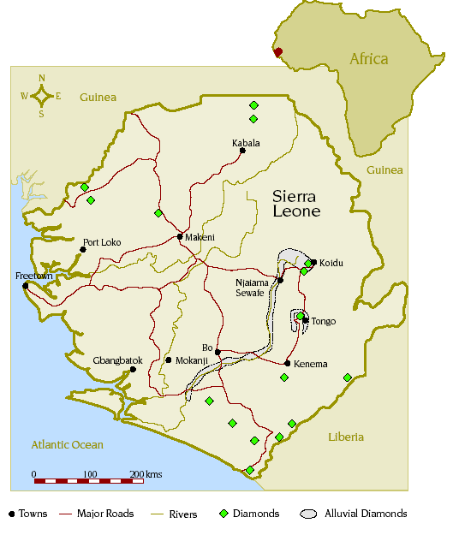Source: Diamond Industry Annual Review Sierra Leone 2004

By the time a diamond rush began in the 1950s, the government gave up policing the diamond districts. Foreign investors provided their own security. To crack down on the growing illicit diamond trade, however, the government tightened security between Kono, a large diamond district, and Freetown, the country's major exporting site. This increase in security caused smugglers to move illicit goods through Liberia, creating the illegal diamond pipeline between Liberia and Sierra Leone.

In 1956, the government introduced the Alluvial Mining Scheme, which allowed many indigenous miners to receive mining and trading licenses. The scheme also resulted in increased illegal mining, as 75,000 illicit miners populated the Kono district. After Sierra Leone gained independence from Great Britain in 1961, diamond smuggling became a political problem, as well as an economic problem. Sierra Leone has not had a stable government since independence; it fluctuates between multi-party democracy and one-party rule. In 1968, populist Siaka Stevens became prime minister, bringing the country to one-party rule. Stevens was the first to officially connect the diamond mines to political power and profit, and he encouraged illicit mining to gain political power. He nationalized the diamond mines and De Beers' SLST by creating the National Diamond Mining Co. Through NDMC, Stevens gave himself and his key advisor, Lebanese businessman Jamil Mohammed, control of the diamond mines. Under Stevens' authority, legitimate diamond trading dropped from more than two million carats.

Artisanally-produced diamonds exported in compliance with the Kimberley Process in the month of October 2004 were valued at US$230 per carat compared with an average value of US$149 per carat for all of 2003, according to data from the Government of Sierra Leone's Gold and Diamond Department (GGDO, of the National Revenue Authority). This increase appears to be the result of improved valuation and businesses exporting more of the larger stones legally. During the month of October 2004, kimberlite exports, from Koidu Holdings, were valued at US$117 per carat.
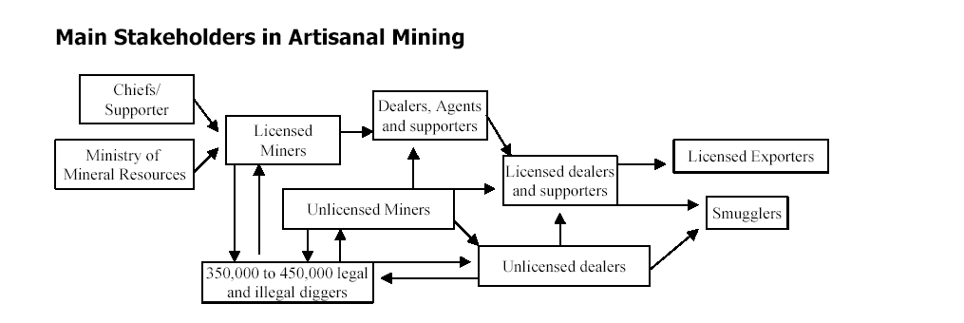
Source: Sierra Leone Diamond Sector Financial Policy Constraints 2003 by Chaim Even-Zohar, of Tacy Ltd.

Artisanal diggers mine alluvial deposits in an exceedingly complex system in which the main stakeholders include diggers, license holders, dealers, supporters and exporters. Holders of alluvial mining licenses operate within an integrated system that requires them to sell their winnings to licensed dealers/agents or to exporters, at prices that are supposedly negotiated on a case by-case basis. The miners’ financial dependency on and legal obligations to their financial supporters prevent the formation of a willing buyer/willing-seller environment that could provide the desired competitive operating theatre. Licensed miners are not authorized to buy rough diamonds from others, although small-scale licensees may export their winnings directly under certain approved guidelines. Other mining stakeholders include the paramount chiefs (who own the land, collect surface rents, and in some cases grant mining rights), the Ministry of Mineral Resources (which owns the mineral rights, issues the mining license, and regulates the industry), and the “gangs” of diggers (who constitute the main labour force). There are also less significant players such as the “coaxers” and the “traffickers.” Dealers often also play an active role in the management and supervision of mining work, either personally or through employees, mostly to protect their investments and assure that winnings are not diverted to smuggling channels or to rival dealers. Finally, licensed exporters (mostly foreign nationals) continue to conduct the formal export of diamonds. In principle, the latter are not supposed to be involved in mining or related supporting activities, but in practice they appear to be a major source of funds for mining.

* Estimated 2001 Diamond Production by Country
Country | Carats  (‘000) | Value  ($ m)
Botswana | 26,416 | 2,194
Russia | 20,500 | 1,650
South Africa | 11,301 | 1,145
Angola | 5,871 | 803
D.R. Congo | 19,637 | 496
Canada | 3,685 | 531
Namibia | 1,502 | 322
Australia | 26,070 | 294
Guinea | 754 | 128
Sierra Leone | 375 | 68
Central Africa Republic | 614 | 92
Venezuela | 325 | 41
Tanzania | 191 | 28
Brazil | 550 | 22
Liberia | 155 | 23
Ivory Coast | 145 | 17
China | 150 | 15
Ghana | 450 | 11
Lesotho | 20 | 4
Guyana | 20 | 2
Total | 110,176 | 7,253
*Source: Mining Journal, London, August 23, 2002
The table above shows in 2001, despite the civil war, Sierra Leone was still the 10th largest diamond producer in the world.

The combination of foreign capital currently flowing into exploration and production and certification is set to boost Sierra Leone’s diamond exports significantly. We believe that on present course Sierra Leone is set to export US$200m of diamonds by YE2005. Given that annual seepage still amounts to between US$250-400m, the actual amount of Sierra Leone’s diamond exports should amount to between US$450-650m. That amount would place Sierra Leone in fifth position of diamond producing countries, ahead or the Democratic Republic of Congo (i.e. DRC).

RUTILE
Sierra Leone possesses one of the largest high grade natural rutile reserves in the world. At the peak of production Sierra Leone accounted for one-quarter of the world’s production. The plant was the single largest US FDI recipient in the entire West African sub-region.

The titanium dioxide mineral was first discovered in 1954 in the gravels of the Lanti River south of the Gbangbama region in the Southern Province. Four groups of deposits are known: the Gbangbama group, the Sembehun group, the Rotifunk deposit and the Kambia deposit. Also, substantial quantities of rutile occur in the gravels of the Little Scarcies River, around the confluence with the Mabole River in Kambia/PortLoko Districts, and as an accessory mineral in the high-grade gneisses of the Kasila Group. The Gbangbama group consists of at least six major mineral sands deposits: Mogbwemo, Bamba-Belebu, Pujubu, Lanti, Gbeni and Gangama. The first three deposits of the Gbangbama group have now been almost completely mined out. Mining has also taken up about 30% of the Lanti deposit but the remainder are in various stages of mine feasibility study and could be classified as mineable. Proven rutile ore reserves total 370 million metric tonnes containing 5.7million tonnes of recoverable rutile.

GOLD
Gold was first discovered in Sierra Leone in 1926 in the Makoke River near Masumbiri, northern Sierra Leone, further prospecting between 1928 and 1930 proved the existence of extensive alluvial goldfields in the Sula Mountains/Kangari Hills in the north and central parts of the country. All greenstone belts in Sierra Leone (with the possible exception of the Marampa Group) are known to contain gold. Rivers and streams draining these areas also carry gold. Prospecting activities by the Geological Survey established the existence of gold in the following localities within the granite-greenstone terrain of Sierra Leone:

1. The Sula Mountains area including Lake Sonfon, Maranda and Yirisen.
2. The Kangari Hills area especially Baomahun, Makong and Makele.
3. The Nimini Hills.
4. The Loko Group Schist belt in the Kamakwie-Laminaia area, northern Sierra Leone.
5. The Gori Hills.

Lode gold deposits occur in the Lake Sonfon area, at Kalmaro, Makong, Baomahun and Komahun. Other goldbearing areas within the granite-greenstone terrain include the Kangi Hills and the Kambui Hills.The Lake Sonfon area contains steeply dipping quartz and pegmatite veins showing sulphide mineralisation and gold, with assay values of up to 32 g/t.

At Kalmaro, mineralised quartz veins and lenses intruding talc-chlorite-carbonate schists have been traced for about 800 m along strike and assay up to 27 g/t. In the Makong area, quartz veins, veinlets and stringers, sometimes with visible gold, occur in the upper reaches of the Kwifwifwi stream. Further exploration in the Makong area has revealed an extensive system of mineralised quartz veins arranged en echelon.

At Baomahun, the gold mineralization is also associated with sulphides and follows the contact between magnetite-rich garnet-cummingtonite schists and cordierite schists. The contact zone is about 100 m wide and extends for about 1,500 m. The Baomahun deposit, mined in the 1950s by Maroc Mining, has been the subject of several studies, with Harry Winston Inc. installing a pilot heap-leach pad in 1990 and driving an adit into the hillside. At Komahun in the Nimini Hills, significant gold mineralisation occurs over an area of about 400 m x 100 m. Drill core assay values of up to 34 g/t and averaging about 8.6 g/t over 20 m have been obtained. Geological Survey studies have delineated significant geochemical anomalies, and Mano River Resources and Afcan Mining are about to start exploration in the area.

Although alluvial gold (i.e. nuggets and dust) have been extracted and sold since its discovery. Sierra Leone currently has no industrial scale gold mine, despite the substantial Gold in the country. We believe that bin the next 3-5 years the country will have at least 1-2 industrial scale gold mines.

BAUXITE
The occurrence of bauxite in Sierra Leone was first recorded in 1920 and 1921 on the road from Falaba to Waia in northern Sierra Leone. Other bauxite occurrences include those between Moyamba and Mano (weathered dolerite sills of the Rokel River Group); the bauxite deposits of the Freetown Peninsula; the Krim-Kpaka deposits in Pujehun District, southern Sierra Leone; and the Kamakwie and Makumre bauxite deposits in northern Sierra Leone. The most important bauxite finds were made by the Geological Survey in the Mokanji and Gbonge Hills in 1960 and by Sierra Ore and Metal Company (Sieromco) in Port Loko in 1972. Sierra Leone bauxite ore has formed from weathering of the hypersthene/ feldspar-rich rocks of the Kasila Group. This forms a high-grade metamorphic belt trending NNW, and is the coastal rim to the West African Craton. Bauxite seems to occur along the entire stretch of the belt from Moyamba in the south, through Port Loko to Kambia District in the northwest.

The Gbonge - Mokanji bauxite belt in the Moyamba District, was mined by Sieromco (a wholly-owned subsidiary of Alusuisse) from 1963 until 1995. The bauxite belt is about 55km wide and strikes NNW. A second bauxite deposit located in the Port Loko area, Northern Province, is the northern extension of the Mokanji bauxite belt.

The Mokanji deposit is variable in quality; blending yields a shipping grade of 55-56% alumina and 3-4% silica. Sieromco was able to attain a maximum annual production of about 1.5 Mt. Transport over short distances to the port at Nitti, situated on one of the numerous outlets of the Sherbro River, was an added advantage. The Port Loko bauxite deposit is of medium grade with about 48% alumina and 3-3.5% silica. Feasibility studies carried out by Sieromco indicated a mineable deposit with reserves of over 100 Mt of which 77.3 Mt are proven. The deposit is easily accessible, and the old iron-ore railway used by Marampa runs right through the deposit, linking it to the port of Pepel. Up to 2.0 Mt/y of iron-ore concentrate was usually shipped from Pepel.

Sierra Leone’s Bauxite mining activity is currently dormant, the largest mine in the country is has the same owner as Sierra Rutile Limited, Mr. Jean Raymond Boulle. We expect bauxite mining activity to resume shortly, helped by the need of thje GOSL to generate income.

PLATINUM
Alluvial platinum was discovered in the Big Water and Whale Rivers around York on the Freetown Peninsula in the late 1920s. It was found in almost all the streams draining the western part of the Freetown basic igneous complex. Platinum was produced between 1929 and 1949 by panning and sluicing of gravels. Total output was about 5,250 oz. The streams carrying the best platinum values have their sources in, or cut across in their upper reaches, an intrusion of coarse-grained anorthosite and anorthositic gabbro.

IRON ORE
Sierra Leone used to be Africa’s seventh largest iron ore producer. Iron ore was first discovered in Marampa in the Port Loko District in the early 1930s and industrial mining commenced soon after and continued until 1976. At its peak the mine was producing 1 million tonnes of ore per annum. Proven reserves currently amount to 537 million tonnes. Vast tailings can still be remined. There are also substantial deposits in the Tonkolili District. The GOSL is willing to provide generous concessions for investors seriously considering restarting mining activity.

OIL
A 2-D seismic survey was conducted by TGS-NOPEC and a bid round concluded in May 2003. Seven offshore blocks were defined covering an area of 17,500 square miles. The south most four out of the seven were awarded leaving Blocks 1,2 and 3 available. Blocks 6 and 7 were awarded to Repsol-YPF, the major Spanish Oil company. Block 5 was awarded to Oranto Petroleum, an independent producer from Nigeria. Block 4 was won by Number 8 Investment Incorporated, a new US oil exploration firm.

The Sierra Leone Blocks have characteristics in common with Angolan deepwater. Earlier work which was done by Mobil gives a good indication of petro-geology.
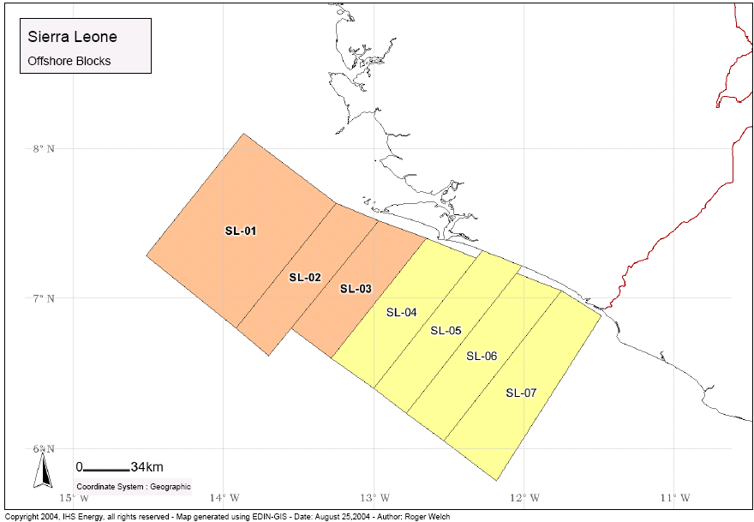

Sierra Leone 2nd Offshore Petroleum Bid round 2004
The Petroleum Resources Unit on behalf of the GOSL recently announced the 2004 Petroleum Bid Round for three blocks (SL1-SL3) totalling about 17,700 square km. The bid period commences 15th October 2004 and closes on 15th April 2005. About 2,700 square km of new 2D seismic data covering these blocks, Well information and Regional Interpretation is available for from TGS-NOPEC.

